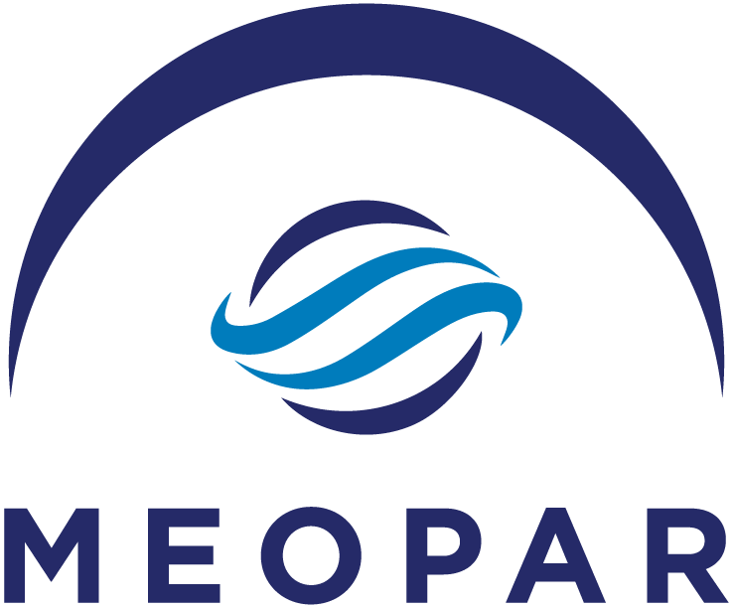

Early Career Faculty
Call for Proposals

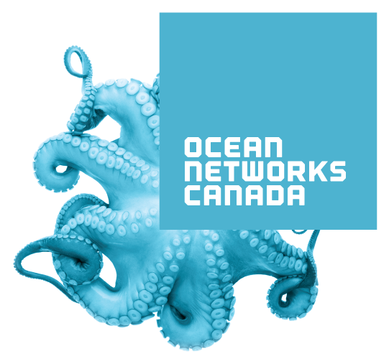

In partnership with Ocean Networks Canada (ONC).

Inquiries

Proponents with inquiries regarding the Early Career Faculty (ECF) grants are encouraged to contact MEOPAR’s Research Program Coordinator, Alexa Reedman at alexa.reedman@meopar.ca or 902-494-2580.

Frequently asked questions will be uploaded to MEOPAR’s website. See www.meopar.ca for more details.

Objective
The Early Career Faculty (ECF) Grants are a unique opportunity for early-career faculty investigators to contribute to and participate in MEOPAR’s broad interdisciplinary, multi-institutional research effort, thereby growing and extending their network of collaborators and interactions with stakeholders. MEOPAR recognized the need for support of early career investigators (who received their first faculty appointment in the last five years) to maximize their considerable potential.

This Call is specifically targeted at individuals early in their academic research careers.

About MEOPAR
Established in 2012 through Canada’s federal Networks of Centres of Excellence (NCE) Program, MEOPAR is a national network of academic researchers and students, government scientists, and partners in the private, NFP and community sectors working together to reduce vulnerability and strengthen opportunity in the marine and coastal environments.

MEOPAR’s vision is to enable Canadian leadership in marine environmental observation, prediction and response, in close coordination with partners, and to deliver knowledge, technology, technique and highly-qualified personnel (HQP) to enhance resilience and optimize economic opportunity for Canada. This will be realized through the development and application of knowledge-based approaches to better anticipate and respond to the risk of the changing marine environment.

MEOPAR’s second funding Cycle (2017-2022) builds on the capacity established during its first Cycle (2012-2017) and focusses efforts on strengthening pathways with partners and end-users. MEOPAR continues to develop multi-sectoral and international partnerships to ensure the delivery of knowledge and technology to partners and end-users for the benefit of Canada.

MEOPAR’s research plan is organized into two themes (Theme 1: Environmental Change; and Theme 2: Human Activity) and is focused on providing research solutions to four Canadian socio-economic challenges:
- The data coordination gap in ocean observation;
- Predictive capacity and environmental forecasts, particularly in the Arctic in support of the Year of Polar Prediction (YOPP);
- Knowledge-based and forecasting solutions to increase coastal community resilience;
- Technology and data solutions that minimize risk and maximize efficiency of marine industry operations, with emphasis on coastal and northern shipping.

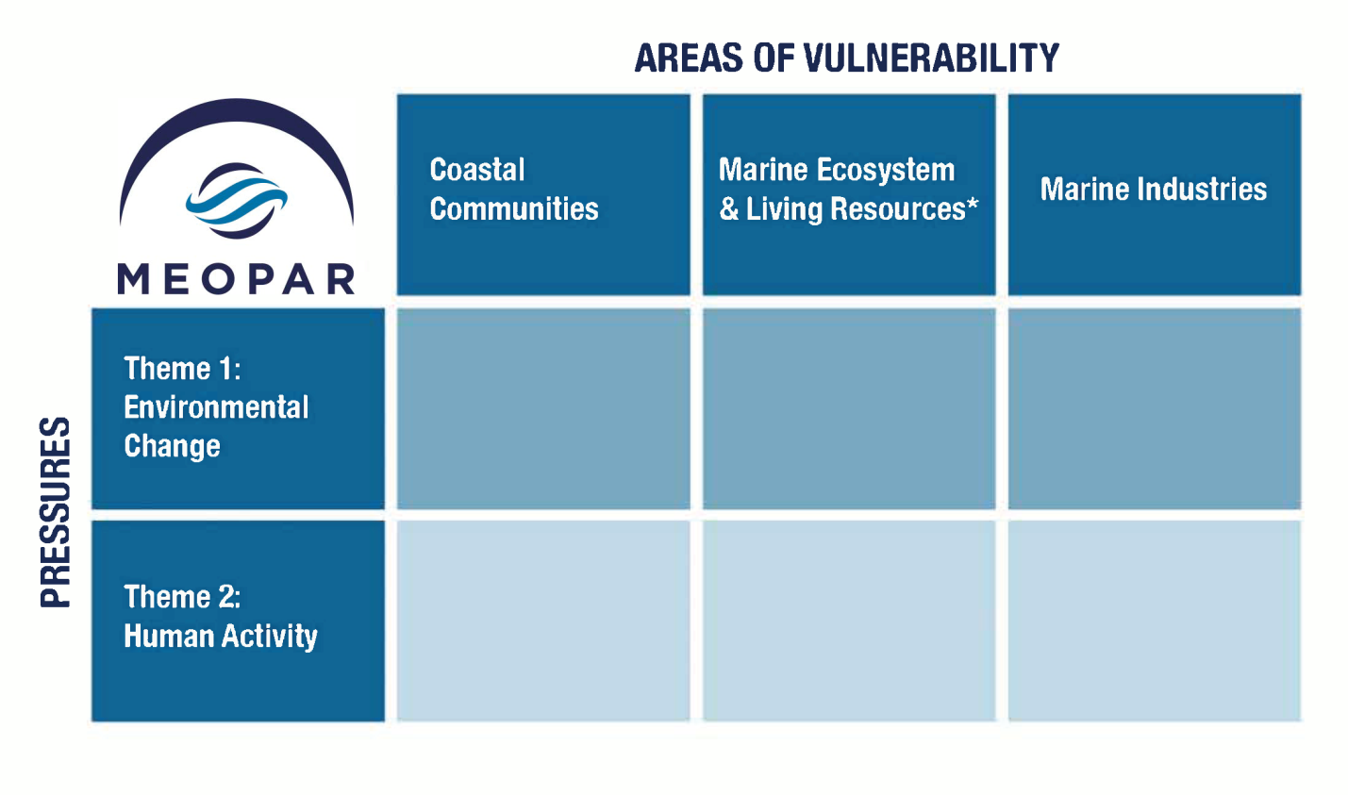
Figure 1. MEOPAR’s Cycle II Thematic Matrix.
*This category also includes industries that depend directly on living marine resources (e.g. the fishing and aquaculture industries).

MEOPAR’s research projects are supported by activities of three Cores: Observation, Prediction and Response. The Cores allow for maintenance and sharing of key expertise, instrumentation and knowledge transfer activities that are of general relevance to MEOPAR projects as well as to closely-related activities. Hence Cores provide technical support and central functions – in the form of equipment, technical expertise, technicians, training, and quality assurance.

More information about MEOPAR’s organizational structure and Strategic Plan can be found on our website http://meopar.ca/about-meopar/strategic-plan.

Structure of the Call
The ECF program provides individual research grants; therefore, the only investigator to receive funds on the project will be the Principal Investigator (PI). Only one application per PI will be considered. There are between 12-15 grants available under this program. The maximum funding level available for each grant is $100,000. MEOPAR will support research projects that are two years in length, beginning in April 2019. Annual funding will be split in half, with the first half administered in April and the second in October.

This Call is released in partnership with Ocean Networks Canada (ONC). The financial contribution of ONC may be applied to any proposal that meets their requirements for funding. Eligibility for ONC funding is detailed in the eligibility section below.

The applicant is encouraged to involve collaborators as part of their project. A collaborator must be qualified to undertake research independently and will be expected to contribute to the overall intellectual direction of the research and bring their own resources to the collaboration.

Applicants are also encouraged to establish links with existing MEOPAR projects and activities. This may be through a formal cooperation with an existing MEOPAR research project, or through a clear explanation of how a distinct research focus is relevant to, and might be integrated with, other MEOPAR research. Descriptions of existing projects are available through our website at www.meopar.ca. Proponents are encouraged to contact MEOPAR’s Theme Leads to discuss how the applicant’s research interests align with the current projects.

Proponents with inquiries regarding Theme 1: Environmental Change are encouraged to contact Susan Allen at sallen@eoas.ubc.ca or Brent Else at belse@ucalgary.ca.

Proponents with inquiries regarding Theme 2: Human Activity are encouraged to contact Jackie Dawson at jackie.dawson@uottawa.ca or Phil Loring at phil.loring@usask.ca.

MEOPAR encourages research projects to involve stakeholders from multiple sectors (i.e. academia, private sector, government, NFPs) in various roles such as participating in research definition, providing data, participating as subjects in the research and/or as end-users for the project deliverables. In keeping with the nature of the NCE program, MEOPAR seeks to build multi-sectoral and interdisciplinary partnerships. International collaborations are considered beneficial to the proposal but not a requirement for application.

Support from external partners (in-kind and/or cash) is beneficial, but is not a requirement for application. Proposals and letters of support should clearly explain the nature of the participation and any financial commitments. Review the NSERC Guidelines on Eligibility and Value of In-Kind Contributions.

Eligibility
Applicants interested in applying to the Call who are unsure about their eligibility should contact Alexa Reedman at alexa.reedman@meopar.ca. Adjunct professors as well as existing and previous MEOPAR project or Core leads are not eligible to apply for these grants. The eligibility conditions are as follows:

- The applicant must be eligible to receive Tri-Council funding. Moreover:
  - The applicant must hold, or have accepted a firm offer of, an academic appointment at an eligible Canadian university at the time of application. For the duration of the award, the applicant must hold such a position. The appointment can be:
    - a tenure-track position; or
    - a term or contract position of no less than three years at the Assistant Professor level or higher.
  - The applicant’s faculty appointment must not be conditional on obtaining the MEOPAR grant or other unconfirmed sources of support.
  - The position must allow the applicant to engage in research that is not under the direction of another individual and must authorize you to supervise or co-supervise the research of students registered in an undergraduate or graduate degree program, and/or postdoctoral fellows (e.g., thesis supervision and not supervision of regular course or laboratory assignments).
  - The appointment must be ratified by the person(s) or body responsible for approving appointments or their delegate(s), and must be in accordance with university statutes.
  - The source of salary funding for the appointment must be guaranteed for at least three continuous years within the period of the contract.
- Initial funding of the project will commence in April 2019. At that time, the applicant must be within five years of their first academic appointment at a Canadian university and within ten years of receiving their PhD.
- The window of eligibility can be adjusted to take into account instances where a researcher has had an acceptable delay in research or period of inactivity (illness, parental leave, etc.). For example, a researcher beginning to receive funding in April 2019 and who took a seven-month parental leave within the past five years must have been hired on or after August 2013 in order to be considered eligible.
- Before any funds can be released on a MEOPAR grant, the applicant must have taken up their faculty position and completed all degree requirements. For ECF grants, this can be no later than the end of March 2019.

This Call is released in partnership with Ocean Networks Canada (ONC). Research eligible to receive ONC funds includes proposals which:
- use ONC data sources (see definition below) to advance development of models or predictive skills that could be operationalized for the benefit of Canada, and/or
- create new or enhanced data products (process, analysis, visualization method or data format) from ONC data sources that will convey complex information and/or highlight key environmental variables, and benefit other observatory users and stakeholders. ONC data sources include:
- Any data source associated with the VENUS Salish Sea Observatory,
- Any data source associated with the NEPTUNE offshore Observatory,
- Any ONC community observatory located along the coasts of BC, the Arctic and the Atlantic,
- Third party data hosted by ONC via the Oceans 2.0 data portal such as Arctic or Atlantic buoy data.

Applicants are encouraged to contact Richard Dewey at rdewey@uvic.ca regarding eligibility for Ocean Networks Canada funding.

Highly Qualified Personnel (HQP)
Our capacity to observe, predict and respond to future marine risk depends on the academic and professional preparation of the next generation of scientists and decision makers. As an NCE, MEOPAR plays a critical role in training the next generation of marine researchers in Canada. Our training program focuses on building trainees' interdisciplinary skills related to marine environmental risk and the required response and policy strategies.
Project-level training initiatives are complemented by Network-level training. HQP on the projects will be expected to participate in the MEOPeer Training network, including the Annual Training Meeting (ATM), regional workshops and webinars. Students will be encouraged to participate in project partner outreach activities.
Applicants are encouraged to contact Laura Avery at laura.avery@meopar.ca with questions about MEOPAR’s HQP Training Program.

Requirements of Funding
Each PI receiving MEOPAR funding will enter into a Performance and Reporting Agreement (PARA) with the Network, which will identify funding schedules as well as the reporting timeline. In the research plan, the PI will describe 3-5 concrete and measurable project milestones (which will be listed in this agreement). PIs will be required to submit an annual report which includes information such as: cash and in-kind funding from partners, a progress report, training and knowledge mobilization deliverables, explanation of any delays to the project’s timeline, etc.

It is the responsibility of the PI to ensure that all necessary certifications, permits, licenses and other approvals have been obtained before any research is carried out in whole or in part (e.g. research involving human subjects, or research with effects on the environment, Indigenous peoples, and animals). If an environmental or ethics assessment is required for the proposal, MEOPAR will need a copy of the appropriate institutional certification committee approval before full funding is released.

Research Impact & Knowledge Mobilization
MEOPAR defines research impact as the effect on, change, or benefit to the economy, society, culture, public policy, government operations, the environment or quality of life. Impact is achieved when knowledge or research fulfils a need of an end-user (e.g., government departments, policy makers, the public, private industry, not-for-profits, etc.) and is applied by that end-user. Knowledge Mobilization (KM) is the process by which research is packaged and transferred to end-users, resulting in impact.
MEOPAR’s research is evaluated by its ability to demonstrate the impact of the research. For this program, a strategy for how the applicant will engage end-users over the course of the project in order to set the scene for future impact is required. This should identify potential end-users and include specific methods and steps as to how they will be engaged. By the end of the project, the applicant should be in a position to translate research from discovery (academic) to impact (end-users). A portion of the budget should be allocated to this activity.
Applicants are encouraged to contact Heather Desserud at heather.desserud@meopar.ca for questions about developing project KM Plans.

Intellectual Property
The ownership of Intellectual Property (IP) supported by MEOPAR research grants is determined by the policies and by-laws of the participating institutions. The authority and responsibility for making decisions regarding the legal protection and commercialization of IP rests with the owners of the IP and/or their institution. MEOPAR asserts no claim to any intellectual property, however, reserves the right to use the results of the research for reporting and promotional purposes which will not be unduly restricted by the investigator, the investigator’s university, nor other project partners. Applicants must consult their own universities in the case of proposals that may involve or generate protected IP.

Successful applicants must sort out any IP issues with partner organizations (if applicable) and provide a signed IP agreement to MEOPAR within 12 weeks of funding notification.

Data Management Plan
Applicants will be required to submit a Data Management Plan (DMP) summary, which summarizes their planned approach to manage the data generated or collected by the proposed research. Plan summaries should include the types of data generated, the formats and metadata the PI expects to employ, how the data will be managed throughout its lifecycle, training and documentation plans for the research team, what resources are required (particularly if the PI has included a budgeted amount), how and when the data will be made available to others (including MEOPAR), and any special considerations impacting data management (e.g. confidentiality, ethics approvals, etc.). Applicants should ensure that DMPs are compliant with MEOPAR’s data policy http://meopar.ca/uploads/Data_Management_Policy_-_September_2017.pdf.

Note: If the proposal is successful, applicants will be required to submit a complete DMP prior to receiving project funds. MEOPAR recommends the Portage DMP Assistant, which has a MEOPAR-approved template, but other formats are accepted if they include the same information.

Budget
A detailed budget with specific breakdowns and justification for each category is required in the proposal. For example, in the “Personnel” section, be specific about the number of people to be hired and their status (Masters student, PhD candidate, Postdoctoral Fellow, Research Associate etc.). If listing in “Equipment” category, specify the type of equipment, approximate cost and rationale for purchase or rental. If listing in “Travel” category, include information such as the intended destinations and number of people traveling. Differentiate between travel required for the research activity, travel related to the Annual Scientific Meeting/Annual Training Meeting (ASM/ATM), and KM activities (e.g., workshops, meetings with end-users/partners, printing costs, website design or other professional services etc.).

Projects must include funding for the PI and one HQP to attend the MEOPAR ASM/ATM for each year the project will receive funding. These will be held jointly in the following locations:
Date | Location
June, 2019 | Victoria, BC
June, 2020 | Ottawa, ON

The budget must be submitted in the format of the attached template (Appendix B). For Non-NCE contributions, indicate in the attached template (Appendix C) whether partner contributions are in the form of cash or in-kind. Review the NSERC Guidelines on Eligibility and Value of In-Kind Contributions. Note that the timing of the first year of the project is April 1, 2019 – March 31, 2020 (also known as “MEOPAR Year 8”). MEOPAR’s fiscal year closes on March 31 and funding will be released in April 2019.

Procedure

Proposals will be submitted via our online grant application portal: https://webportalapp.com/sp/login/meoparsubmissionportal

See attached “Appendix D” for portal instructions.

Keep submission sections to the word or page limits indicated. Reviewers will not receive information after the noted limit (e.g., if a letter of support is included that is 3 pages long, the reviewers will not read the third page).

For PDF uploads, documents are to be single-spaced (no more than six lines per inch), regular 12-point font, with margins of 0.75”.

- General Project Information
- List the proposal title and identify amount of funding requested.
- Identify whether the proposal is eligible for Ocean Networks Canada (ONC) funding.
- Identify whether the proposal requires an environmental assessment and/or an ethics assessment.

- Research Impact Summary (maximum 250 words)
  - Clearly articulate the research to be completed (in plain language), its value or potential for impact for Canada, and any already identified applications or uses for partners/end-users. This description may be used externally in media releases, other communications, or by MEOPAR to promote our Network to partners.

- Fit to Network: MEOPAR’s Strategic Plan (maximum 250 words)
  - Explain how your project will advance MEOPAR’s Strategic Plan, and identify one or more of the four challenge areas that your project addresses, and how it fits within the thematic structure (both available on the MEOPAR website).

- Research Plan (maximum 5 pages – PDF upload)

Problem(s) to be addressed, including overview of the state-of-the-art developments in research topic.

Methodological approach.

Anticipated research results.

Innovation and significance of research.
  - Provide 3-5 concrete and measurable project milestones (that will be used in MEOPAR’s PARA) and their associated timeline.
  - Include a description of connections to your prior or ongoing research activities, if applicable.
  - A statement of future perspectives that lie beyond the proposed MEOPAR funding period including future participation in MEOPAR activities.

- Fit to Network: Linkages to Current MEOPAR Research (maximum 250 words)
  - Describe existing or potential linkages to other MEOPAR activities and/or existing projects.

- Highly Qualified Personnel (HQP) – (maximum 500 words)
  - Provide a short statement of your training philosophy. See NSERC’s FAQ document (Questions 4-6) more details on what to include.
  - List the anticipated number of HQP, and their roles, that will be engaged in the project.
  - Describe how HQP training may meet any capacity gaps in the sectors with which the proposal is aligned and how the trainees may benefit from this in their career development.
  - Identify any potential opportunities for advanced training and/or partner-engaged internships through MITACS or other internship programs.
  - For postdoctoral fellows, briefly describe the career development plan for each.

- Excellence of the Researcher(s) (maximum 500 words)
  - Explain the expertise and role the PI and each key collaborator bring to the project, including any experience with interdisciplinary and collaborative research, knowledge mobilization strategies, engaging end-users/partners, and in training students.

- Knowledge Mobilization Plan (250 words)
  - Identify existing or potential partners, how they will be engaged and why they might be interested in the research.

- Need: Partner/End-User Support (maximum 250 words)
  - Provide information about any existing partners, and how they will support and/or utilize your research.
  - Describe the nature of their contribution.
  - Values of cash and in-kind contributions listed in this section are to appear in Appendix C.
  - Content of partner contributions should be reflected in attached letters of support.

- Data Management Plan Summary (maximum 250 words)
  - Outline your data management strategy, including the types of data generated, the formats and metadata you expect to employ, what resources are required, and when the data will be made available.
  - If the proposal is funded, the PI will be required to submit a full Data Management Plan.
  - Data Management Plans must align with MEOPAR’s Data Management Policy, available on MEOPAR’s website: http://meopar.ca/uploads/Data_Management_Policy_-_September_2017.pdf.

- Budget and Non-NCE Contributions (Appendix B & C – Excel upload)
  - Use the budget template provided (Appendix B).
  - Be specific on budget line items (as noted in section G).
  - Include travel expenses to MEOPAR’s ASM/ATM for the PI and one HQP for each year the project is funded.
  - Use the non-NCE contributions template (Appendix C).

- Budget Notes and Justification (maximum 500 words)
  - Include budget notes and justification for expenses.
  - Where it says “specify” in the budget template, explain in the notes and justification.
  - If applicable, make note of in-kind contributions towards the proposal.

- Citations/References (maximum 1 page – PDF upload)
  - List recent, proposal-relevant academic and other professional publications.

- Curriculum Vitae (PDF upload)
  - CVs may be submitted in any of the standard Tri-Council formats including the draft version generated through the Canadian Common CV website.

- Letter(s) of Support (maximum of 2 pages each)
  - The content of these letters should reflect the commitments of partners described in the “Partner/End-User Support” section (including things such as cash, in-kind, data, personnel, etc.).
  - There is no limit on the number of letters of support.

- Submission Timeline
The application deadline for this Call for Proposals is 4:00 p.m. Atlantic Time, Monday, October 29, 2018. MEOPAR’s online system will not accept submissions after the deadline.

An automatic acknowledgement of receipt will be provided by the system.
MEOPAR’s Research Program Coordinator will provide an initial compliance screening. Proposals that do not follow these requirements explicitly will be returned to the applicant (PI) and given a 24-hour period to comply and resubmit. Proposals that still do not comply with these criteria or miss the 24-hour resubmission timeline will not be considered for funding.

- Proposal Evaluation
The Research Management Committee will review all proposals and evaluate them in three key areas. Proposals will be rated on a 0-5 scale.

0 – The proposal fails to address the criterion or cannot be assessed due to missing or incomplete information.
1 – Poor. The criterion is inadequately addressed, or there are serious inherent weaknesses.
2 – Fair. The proposal broadly addresses the criterion, but there are significant weaknesses.
3 – Good. The proposal addresses the criterion well, but a number of shortcomings are present.
4 – Very Good. The proposal addresses the criterion very well, but a small number of shortcomings are present.
5 – Excellent. The proposal successfully addresses all relevant aspects of the criterion. Any shortcomings are minor.

- Excellence of the Research and Principal Investigator (45%)
Mandatory elements:
  - The proposed research is innovative and/or original and has the potential to produce valuable advances.
  - The proposal addresses an issue with a clear knowledge, technology and/or research gap.
  - The Principal Investigator and key collaborator(s) have the appropriate research expertise and excellence to deliver on the proposed research plan.

Preferred elements:
  - If applicable, the Principal Investigator and key collaborator(s) integrate multidisciplinary expertise in a convincing way.
  - If applicable, the Principal Investigator and key collaborator(s) include multi-sectoral expertise with the commitment and capacity to contribute usefully to the project objectives.
  - The proposal includes international participation with clear relevance/utility to Canada.
- Impact, Need and Fit to Network (25%)
Mandatory elements:
  - The proposal links strongly to MEOPAR’s strategic plan
  - The proposal states the project’s anticipated impact (in plain language) and provides a rationale as to why it will benefit Canadian society, economy and/or environment.

Preferred elements:
  - The proposal and letters of support demonstrate clear end-user/partner involvement in the project/question formulation, the research activities (where appropriate), and in putting the research to use.

  - The proposal links to current MEOPAR research and Core activities.
  - There are letters of support from a wide range of partners and end-users in various sectors (e.g. academic, government, NFPs, municipalities, etc.)

- Training (20%)

Mandatory elements:
  - There is a clear plan for value-added training of HQP, including opportunities for interdisciplinary learning, cross-sector engagement, and professional development.
  - HQP training will address capacity gaps in the sector(s) with which the proposal is aligned, and the trainees will benefit from the training in terms of career development.

Preferred element:
  - The training plan includes direct involvement from non-academic partners, such as partner-engaged internships through MITACS or other internship programs.

- Management and Implementation (10%)
Mandatory elements:
  - The proposal deliverables, timeline, and methodologies are clearly defined and realistic.
  - The KM plan is realistic.
  - The data management plan is appropriate, feasible and consistent with the MEOPAR data management policy.
  - The budget has the appropriate resources assigned to accomplish research, training, KM activities and attendance at the ASM and ATM for investigators and HQP.

Preferred element:
  - There is a significant and quantifiable cash and/or in-kind contributions from partners/end-users.

Questions?
For all questions about the ECF grants, please contact Alexa Reedman, Research Program Coordinator at alexa.reedman@meopar.ca. MEOPAR will post questions and responses to questions on MEOPAR’s “Call for Proposals” webpage, under “FAQs”.

Glossary of Terms

- Collaborator: Researchers who do not receive funding but who are involved in the research project. They can be from an academic institution, government agency, industry partner, etc.
- Core: a main mechanism through which MEOPAR provides research support to projects and the Network.
- End-user: Non-academic stakeholders (e.g. government departments, policy makers, the public, private industry, not-for-profits, etc.) who apply research results or knowledge, resulting in research impact.
- Highly Qualified Personnel (HQP): Trainees and research staff such as undergraduate and graduate students, postdoctoral fellows, research associates, research assistants, technicians, and summer students.
- Investigator: Researchers who are involved in the research project and receive funding.
- Knowledge Mobilization (KM): The process by which research or knowledge is co-produced and shared with end-users or partners. KM aims to get information to influential people or organizations, at the right time, in the appropriate format, in order to facilitate evidence-based decision making.
- Not-for-profit organization (NFP): An organization created and operated to contribute to the public's benefit, wherein all revenues that go beyond operating costs go back into the organization.
- Non-governmental organization (NGO): A category of NFP that functions independently of government.
- Partner (contributor): An organization providing cash and/or in-kind contributions in support of the activities of a project.
- Principal Investigator (PI): The lead investigator on a research project who has overall responsibility for the research grant as well as the MEOPAR Performance and Reporting Agreement (PARA) for the project.
- Project milestone(s): Concrete and measurable timeline steps that the project must complete.
- Research deliverable(s): Refers to the research results or knowledge resulting from a project that can be mobilized for use by partners or end-users. Examples include: exploitable scientific results, reports, guidelines/standards, training activities/learning modules, software/modelling tools, products, prototypes, services/tools, multimedia, and data.
- Research impact: The long-term effect that the research-informed products, policies, and services have on the environment, economy, society, or quality of life (e.g. job creation, safer maritime shipping regulations, more effective coastal community adaptation strategies, improved understanding of ecosystem services, etc.)
- Research Management Committee (RMC): Reviews proposals, monitors the progress of the Network funded projects, and makes recommendations to the MEOPAR Board on the activities, budget allocations, and the personnel involved in the Network.

Network investigators who have not been project or Core leads may be eligible.
This interpretation of scores is based on the Horizon 2020 model.

