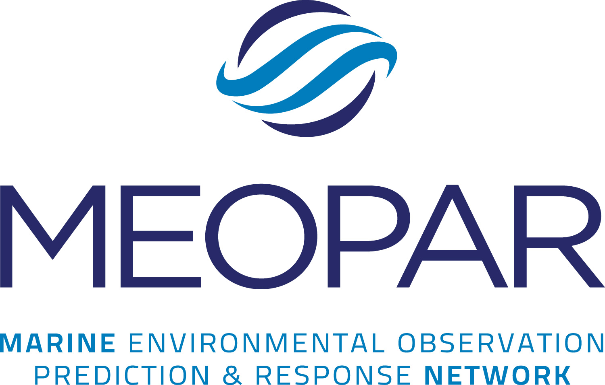

Partnership Workshop Program Guidelines and Call for Proposals


Summer 2015

I. General Information on MEOPAR

The Marine Environmental Observation Prediction and Response Network (MEOPAR) is a team of outstanding, Canadian natural and social scientists working to reduce our vulnerability to marine hazards and emergencies. Presently, over 50 MEOPAR researchers from 11 universities and 4 federal departments are collaborating on 7 research projects, but our network and projects are growing.
MEOPAR is funded by the Government of Canada’s Network of Centres of Excellence Program and was established in 2012.

MEOPAR’s vision is to inspire and enable Canadian leadership in marine environmental observation, prediction and response. MEOPAR is delivering knowledge, technology, and people to enable Canada’s communities and industry to enhance resilience and economic opportunity through an informed relationship with the changing marine environment.

MEOPAR's seven goals, through which it will deliver on its vision, are:

An operational network: Promote an operational network for marine observation, prediction and response along Canada’s coastline through a cooperative approach linking government agencies, academia, municipalities, non-governmental organizations and ocean-related industries.

Information and knowledge exchange: Improve sharing of information and knowledge between communities, private and public sectors, non-governmental organizations, academia and government in order to improve response capability and resilience in the face of changing patterns of risk in the marine environment.

Northern hazard assessment: Provide scientific information and evaluation of marine hazards to guide economic and community development in Canada’s northern marine environment.

Private-sector participation: Strengthen Canadian private-sector expertise in marine environmental observation, prediction and response and promote this expertise to address national and international problems

International cooperation: Promote international cooperation in marine environmental observation and prediction, including adoption and leverage of international best practices and expertise for the benefit of Canadians.

Fundamental research: Enhance resilience through development of new understanding of marine hazards and associated vulnerabilities, and improved ability to predict and project risk.

Economic opportunity: Create economic opportunity through enhancement of resilience as well as through commercialization and application of new approaches to marine observation and prediction.

The MEOPAR network works closely with government agencies, industry and international partners to develop new mechanisms for the sharing of expertise, data, infrastructure, and approaches relevant to anticipating and responding effectively to marine emergencies. With a projected lifetime of up to 15 years MEOPAR will have fundamental impacts on Canada’s preparedness in the face of marine hazards.

Through this initiative to fund workshops, MEOPAR aims to expand and strengthen its network by supporting activities that will encourage new partnerships, generate new ideas for research directions or applications, and enhance knowledge transfer.

II. Workshop/Networking Event Proposals

A. Aims of MEOPAR Workshops

The Partnership Plan outlines how MEOPAR will develop and sustain strong partnerships between academic researchers and industry, all levels of government, non-governmental organizations (NGOs), community groups, associations, and other research networks (http://meopar.ca/what-we-do/).

Under the Partnerships Workshop Program eligible Canadian researchers are encouraged to propose and organize workshops that will contribute to MEOPAR’s strategic goals, preferably by involving a variety of academic and non-academic partners.

Example outcomes of MEOPAR workshops include:
- Strengthening the alignment of existing MEOPAR research projects with activities and needs of partners and user groups;
- Generation of novel project ideas and consortia for MEOPAR to explore via future Calls for Proposals;
- Initiation of cooperative agreements for data and/or equipment sharing between academic and non-academic institutions;
- Establishment of partnerships for knowledge mobilization, training and education, testing and implementation of new technologies, or commercialization of research outcomes;
- Promotion of research collaboration, alignment and cooperation across multiple sectors of society, including government, NGOs and the private sector;
- Mobilization of national and international capacity to identify best practices for management of risks of the marine environment;
- Support of Canadian participation and leadership in international consortia and research coordination actions.

MEOPAR has a total budget of $200,000 to support workshops.

B. Eligibility and Requirements

Eligibility
- The applicant for workshop funding must hold an academic appointment at an eligible Canadian university. A non-academic party that wishes to collaborate on a workshop with MEOPAR should contact our office for advice.
- An individual researcher or MEOPAR project group may apply only once per 12-month period for funds to support a workshop or networking event aimed at engaging non-academic partners for at least one of the purposes outlined above;
- The maximum amount of funding available per event is $15,000;
- The event must involve at least one organization that is not currently partnered with MEOPAR, nor in any other project involving the applicant;
- Events which have contributions (cash or in kind) from one or more participating organizations will be rated more favourably;
- Funds may be used for event-related expenses, such as advertising, personnel costs for workshop support, room and equipment rental, catering, non-alcoholic refreshments, and travel for participants (national and international) as needed, in particular for invited speakers (please note that travel costs for Canadian federal government employees are not eligible);
Responsibilities
- MEOPAR must be acknowledged and promoted at the workshop (e.g. use of logo, short presentation, banner display, etc.);
- Upon notification of funding, the organizer will be expected to contribute information about the event for inclusion on the MEOPAR web page.
- Within one month after the event, a written summary report, plus at least five pictures, must be submitted to MEOPAR. A copy of the agenda/program, any PowerPoint presentations (when available with presenter release), and links to other web sites is also required. This material will be used by MEOPAR staff to promote workshop activities and impacts (attached).
- All supporting financial documentation must be provided to confirm the MEOPAR-funded expenses.
C. Procedure

Applicants should ensure their proposed activity meets MEOPAR’s strategic objectives and requirements. To discuss a proposed workshop, both academic and non-academic applicants may contact MEOPAR’s corporate centre at 902-494-4384 or via email at info@meopar.ca.

Please fill out the application form to apply for funding (attached). Submissions will be accepted until September 2016 or until funds are exhausted (which will be noted on the MEOPAR website). The
application should be made at least 2 months ahead of the intended event to allow time for evaluation. All workshops/networking events must be completed before December 31, 2016.

D. Evaluation
Applications will be pre-screened by the MEOPAR Corporate Centre for general suitability, relevance to the Strategic Plan, and adherence to requirements as set out herein. Unacceptable submissions will be returned to the proponents with feedback on the deficiencies.

A committee composed of the Associate Scientific Director, the Executive Director, and one other member of MEOPAR’s Research Management Committee (RMC) will formally review applications that pass the pre-screening.

1 | Alignment with MEOPAR Objectives
1.1 | MEOPAR Strategic Goals. The proposed workshop must link strongly and convincingly to one or more of MEOPAR's strategic goals.
1.2 | End-User Involvement. End-users must be involved closely in the formulation and proposed delivery of the proposed workshop.
1.3 | Eligibility. The academic applicant must be eligible to receive funds.
2 | Multi-Sectoral Structure and Support
2.1 | Involvement of Multiple Sectors. The workshop should involve multi-sectoral partnership, preferably at least three sectors (industry, government, NGOs, communities, etc.).
2.2 | Builds on Existing Initiatives. The workshop should propose convincing integration with, and extension of, existing Canadian initiatives.
2.3 | Leverage. Proposals with cash and/or in-kind contributions from external sources will have more chance of being funded.
3 | Merit of the Proposal
3.1 | Clarity of Outcomes. The proposed workshop must have clearly defined and measurable outcomes.
3.2 | Social implications of workshop topics. The workshop must address the social and/or policy implications of the research topics under consideration.
3.3 | Project Feasibility. The proposed objectives, budget and timelines must be clear and realistic.

Partnership Workshop Program

Application for Funding

Applicant Identification
Date of application:
Salutation (Dr./Mr./Mrs./Ms.): |  |  | First name (include middle initials): |  |  |  | Family name:
Title (professor, etc.):
University/Organization Name:
Street or P.O. Box:
City, Province, Postal Code:
Telephone: |  |  |  |  | E-mail:
Workshop Details
Title of Workshop:
Start and end date of workshop: |  |  |  | Location of workshop (city and venue): |  |  |  | Funds ($ amount) requested from MEOPAR:
Total number of participants expected:

Workshop Description

What themes will be covered and how will they contribute to MEOPAR’s strategic goals?
What social/policy issues will be addressed?
Please provide a list of the likely participants and their affiliation, other invited organizations and other partners, affiliates.
What benefits and outcomes do you expect as a result of this workshop?
Other Funding Support Requested and/or Secured
Please list below other universities/organisations involved (do not use acronyms) and funding amounts you have requested and/or secured (add as many lines as required):
Budget Details
Please insert the budget information for your partnership workshop or event.

Payment Details
Bursar or Accounts Receivable information required for payments to eligible institutions.
Salutation (Dr./Mr./Mrs./Ms.): |  | First name (include middle initials): |  |  |  | Family name:
Title:
Institution:
Research account #
Telephone: |  | Fax: |  | E-mail:

Please send your completed application to:

E-mail: info@meopar.ca

If you require more information please contact:
Neil Gall  Executive Director  Tel: 902-494-4386  neil.gall@meopar.ca | Dr. Ronald Pelot  Associate Scientific Director, MEOPAR  Tel: 902-494-6113  ronald.pelot@dal.ca

Partnership Workshop Program

Final Report

Please provide a written report summarizing the impact of your workshop/networking event towards the achievement of MEOPAR’s mandate and metrics.

Today’s Date: | Award Date:
Applicant / Institution:
Workshop Title:
Workshop Location:
Workshop Date:
MEOPAR $ Awarded: |  | MEOPAR $ Spent:

NOTE: Please attach a copy (scanned, PDF is acceptable) of any promotional materials, publications, agendas, etc. that were created and provide the links to any relevant Web sites. Please also provide 3-10 photos in jpeg format, with participants’ names/captions.

Event Highlights

How many total participants were involved? How many were from MEOPAR, new academics, students (MEOPeers) or other partners? Please specify total numbers above and attach participants list (where available).

Total # of Attendees | # of MEOPAR Researchers | # of MEOPeers | # of Companies, NGOs, End Users

Impact Statement
Please provide a short quote on the impact of this funding (may be used for promotional purposes on our web site or in our Annual Report).

Please Respond to the Following:

- Please outline the overall workshop/networking activity.

- What were the goals/objectives of the original proposal? How were those goals accomplished? (If modifications were made to the workshop/goals please describe.)

- Please outline how MEOPAR was highlighted/acknowledged at this event. Please specify or attach information or examples.

- What went well? What could have been done differently?

- If applicable, was the event partnership successful to organize this event? What contributed to the success or challenges faced?

- Was the budget sufficient?

- Did the MEOPAR funding help leverage additional funding? If so, how much?

- Would you recommend this workshop format/program/speaker to other MEOPAR Members (if applicable)?

- Would you organize a similar workshop/event again? What changes would you make?

- How did this workshop/event help meet our MEOPAR mandate? (e.g. Were any new academic or end user partnerships formed, new projects created, or end users identified as a result of this workshop?)

- What if any other impacts can you report to date that can be tied to this event?

- Do you have other comments to share?

Please complete and return to MEOPAR’s corporate office: info@meopar.ca within one month of your event.

Prepared by: Date:

