NETWORK OF CENTRES OF EXCELLENCE
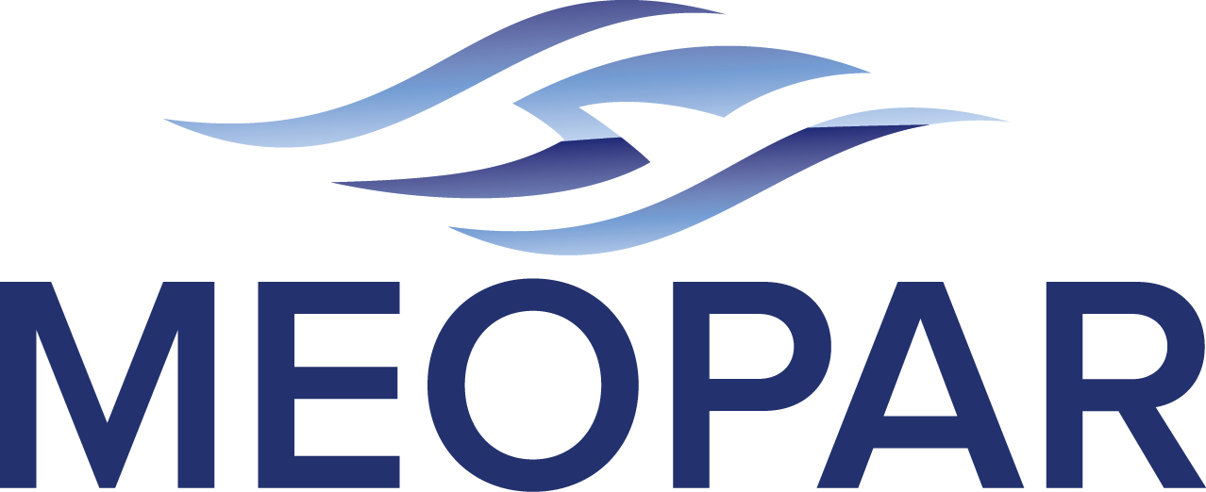
STRATEGIC PLAN 2012-2017

2012/2013 Version
December 18, 2012

(subject to final approval by MEOPAR Board)

Foreword
It is a pleasure to present the strategic plan for the Marine Environmental Observation, Prediction and Response (MEOPAR) Network of Centres of Excellence. The MEOPAR Network offers unique opportunities for Canada’s scientists, policymakers, industries and communities to address risks within the marine environment. The Network is timely: the ongoing coincidence of economic and societal pressures and new opportunities with major environmental change provides both the context and the challenge for the MEOPAR Network. Risk associated with the intersection of technological innovation and marine hazards is not new, but the scale, complexity and cost of accidents and disasters have increased dramatically in recent decades, as illustrated by ocean-related events of this century (e.g. Katrina, Deepwater Horizon, Fukishima).
The word “anticipation” captures the essence of this new Network of Centres of Excellence. This word’s meaning covers prediction based on observation or experience, and can imply action to mitigate or prevent something bad from happening. Yet the word can also convey a more positive sense of expectation that something beneficial or pleasant lies ahead. The key to our future relationship with the ocean will be to “anticipate” or, more precisely, to use science and technology to link observation, knowledge, understanding and experience to actions which reduce risks and enhance opportunities and benefits. This is what the MEOPAR Network’s scientists, students, technicians and specialists aim to achieve in cooperation with their partners in communities, government and industry.

Doug Wallace Robert Walker
Scientific Director, MEOPAR Board Chair, MEOPAR

December 2012

Preface: Planning and Policy Instruments for MEOPAR

The MEOPAR Network will operate according to a hierarchy of plans covering its various activities as illustrated below. These plans will be written for a 5-year horizon but will be updated annually, along with MEOPAR Inc.’s policies, in order to maintain maximum flexibility within the Network.
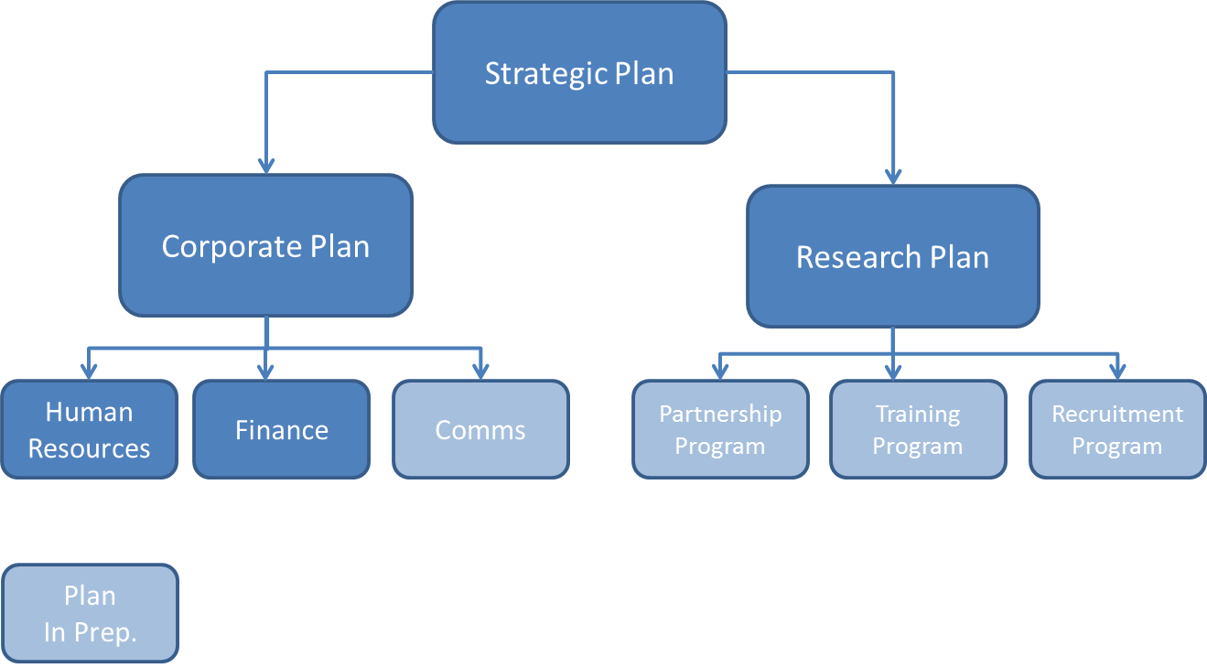
Plan Hierarchy for the MEOPAR Network.
MEOPAR Inc.’s overall direction and mandate are outlined in the following strategic plan. This document articulates a vision for the Network and how products and services developed by and within MEOPAR will be transformative in the areas of marine observation, prediction and response. MEOPAR’s research plan outlines the initial projects of our Network as developed by the Research Management Committee under the leadership of the Scientific Director.
MEOPAR’s corporate plan has been prepared and will be implemented by the Network’s Administrative Centre (i.e., MEOPAR, Inc.), under the guidance and leadership of the Network Manager. The plan speaks to the corporate functions of the Administrative Centre: human resources, communication, and finance and the Centre’s role in ensuring that the Network complies with NCE guidelines and the corporate, financial, and HR policies adjunct to this plan.
Finally, MEOPAR Inc. is guided by both its governance structure including the terms of reference of the various Board committees and its by-laws at time of incorporation which are also annexed to this plan.
- The Context for MEOPAR

Changing Risk Patterns

The marine environment has always presented humankind with great economic opportunities coupled to major risks. It remains the most dangerous place on Earth to extract resources, and amongst the most difficult environments on Earth for transportation, construction and human development. Because of this, the ocean has played host to a long series of accidents and disasters throughout history. However our present relationship with the ocean is impacted by the confluence of two “rivers of change”: environmental change on the one hand and changing economic and societal use of the marine environment on the other (see Figure S1).

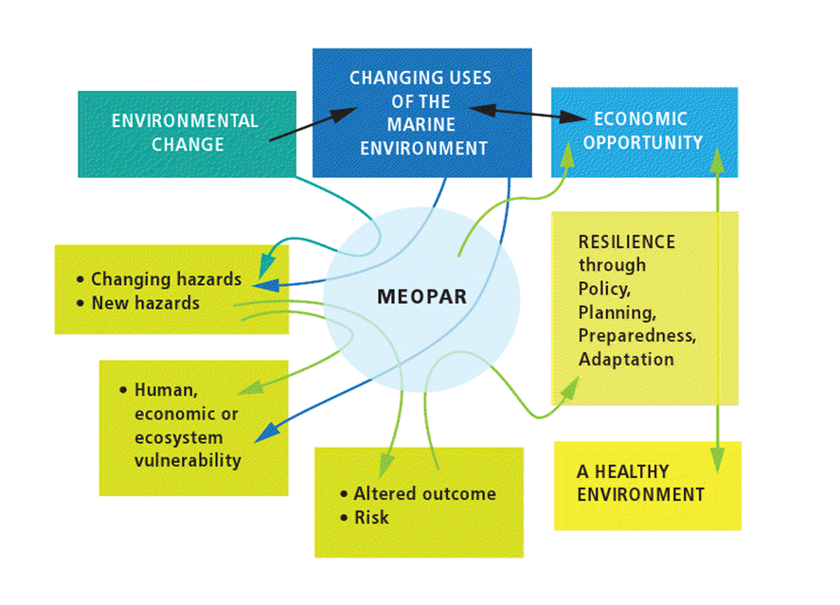

Figure S1. The societal, environmental and economic context for MEOPAR.

A rapid and worldwide change in the economic use of the ocean is underway, including the introduction of fundamentally new uses (e.g. cruise ships in the Arctic; ever deeper search for oil; deliberate manipulation of ecosystems or geoengineering). On the other hand, the oceans themselves are changing, both as a result of natural variability and increasingly, at local, regional and global scales, as a result of human activities. As a result we are facing new patterns of risk from existing hazards and fundamentally new hazards that we have not had to deal with before.

The MEOPAR Network recognizes that, given these changes, it is not sufficient to base policy and planning on the risks of the past or even today. Rather Canada must anticipate and prepare for the emerging risks of the future. Preparedness and resilience, in turn, will require an approach that addresses not only technology and the physical environment, but also human interactions and economic relationships with the broader natural environment.

MEOPAR also recognizes that the ongoing changes present economic opportunities, both through the development of approaches that make economic uses of the ocean less risk-prone as well as through development and marketing of tools and techniques that can be used to better observe, predict and respond, or adapt, to marine hazards.
- MEOPAR’s Vision and Strategic Outcome

Vision – MEOPAR will inspire and enable Canadian leadership in marine environmental observation, prediction and response.

Strategic Outcome – MEOPAR will deliver knowledge, technology, and people to enable Canada’s communities and industry to enhance resilience and economic opportunity through an informed relationship with the changing marine environment.

MEOPAR’s Role

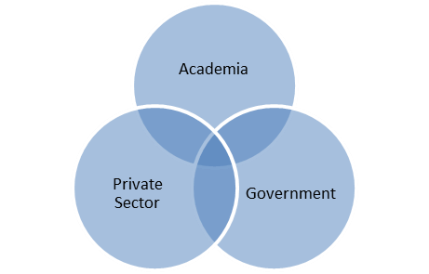

Figure S2. MEOPAR’s research will involve multi-sectoral partnerships.

Canada, being bordered by three oceans and with the world’s longest coastline, faces unique geographical challenges for establishing marine observation, prediction and response capability. With a rapidly changing ocean, most spectacularly to the North, as well as growing offshore and deepwater oil and gas activity, changing shipping patterns and a rapidly changing fishery and aquaculture industry, Canada’s marine environment and economy faces a broad array of change.
The national context for MEOPAR includes broadly-distributed governmental responsibility for preparing for, and responding to, emergencies and risks. This includes a number of Federal Ministries and agencies, provincial emergency management organisations, communities and, of course, ocean-related industries. This broad responsibility has important implications (see text box):
“It is important to acknowledge both the foreseeable and unforeseeable issues that may shape future vulnerability, hazards and disasters in Canada” and that “by encouraging all segments of society, including individuals, communities, private and public sectors, non-governmental organizations, and academia to take responsibility and participate in emergency management, whole-of-society resilience can be achieved”.
From “An Emergency Management Framework for Canada” prepared by the Ministers Responsible for Emergency Management under the auspices of Public Safety Canada

Until now, Canada’s academic and private sectors have not been linked strongly to government efforts to anticipate and prepare for risks of the marine environment. This implies potential for synergy and new approaches that the MEOPAR Network of Centres of Excellence can exploit and develop. MEOPAR will enable Canada’s academic research community as well as private sector and other non-governmental partners to “take responsibility” and “participate” in this important national undertaking with government. The Network will establish a multi-sectoral approach to delivery of research, knowledge and new capabilities which can be translated into improved operational and management procedures.
MEOPAR’s strategy concerning research will be to build, whenever possible, on relevant prior initiatives and to link capabilities of industry, government and non-governmental partners. Hence MEOPAR will build on past successes and network, complement, enhance and add value to ongoing Canadian initiatives. The Network will also cooperate with and learn from related international programs.
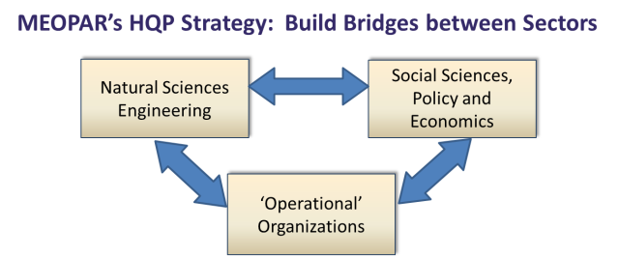
MEOPAR’s strategy concerning knowledge mobilization will ensure rapid flow of ideas, tools and technologies to partners and receptor groups in order to maximize the social and economic benefits of the Network’s research. The strategy involves bringing researchers and users together within research projects, as well as a novel Partnership Program which will co-finance collaborative research with industry, municipalities and other non-academic partners. MEOPAR will promote a variety of mechanisms for information exchange, including an annual Expert Forum aimed at key decision-makers and stakeholders. Commercialization will make use of cooperation with existing national centres.

Figure S3. MEOPAR and Training.

MEOPAR’s training strategy aims to produce multi-skilled people with understanding and expertise across a wide range of disciplines: from the natural and social sciences, to policy and law. The strategy involves creation of a training environment linking natural sciences with economics, social and policy sciences using i) the Network’s own integrated projects, ii) strong interaction among trainees across the Network, iii) internships that promote cross-sector training; iv) direct involvement of partners and stakeholders in the training program, and v) empowerment of trainees to participate in organization of their own training.
- Goals of the Network
MEOPAR is hosted at Dalhousie University but currently brings together over 40 researchers and HQP in 16 institutions from Victoria to St. John’s and this number is growing. MEOPAR’s Administration Centre, located on Dalhousie University’s campus consists of a Scientific Director, a Network Manager, an Executive Administrative Officer, a Communications Officer and a Training Coordinator.
MEOPAR will work closely with government agencies, industry and international partners to develop new mechanisms for the sharing of expertise, data, infrastructure, and approaches relevant to anticipating and responding effectively to marine emergencies. The MEOPAR Network of Centres of Excellence will have a lifetime of up to 15 years. This will allow MEOPAR to have fundamental impacts on Canada’s preparedness in the face of marine hazards. The Network's seven goals, through which the Network will ensure a long-term focus on tangible results andby which it will deliver on its vision and strategic outcome, are:

- An operational network: Promote an operational network for marine observation, prediction and response along Canada’s coastline through a cooperative approach linking Government agencies, academia, municipalities, non-governmental organisations and ocean-related industries.

- Information and knowledge exchange: Improve sharing of information and knowledge between communities, private and public sectors, non-governmental organizations, academia and government in order to improve response capability and resilience in the face of changing patterns of risk in the marine environment.

- Northern hazard assessment: Provide scientific information and evaluation of marine hazards to guide economic and community development in Canada’s northern marine environment.

- Private-sector participation: Strengthen Canadian private-sector expertise in marine environmental observation, prediction and response and promote this expertise to address national and international problems

- International cooperation: Promote international cooperation in marine environmental observation and prediction, including adoption and leverage of international best practices and expertise for the benefit of Canadians.

- Fundamental research: Enhance resilience through development of new understanding of marine hazards and associated vulnerabilities, and improved ability to predict and project risk.

- Economic opportunity: Create economic opportunity through enhancement of resilience as well as through commercialization and application of new approaches to marine observation and prediction.
- Objectives for the First 5 Years

MEOPAR’s research program includes development and integration of science-based technologies and tools to improve Canada’s ability to respond to marine emergencies as they occur, and anticipate and adapt to changes in the risk of marine extremes and emergencies over the next century. Over its first 5 years, the Network’s effort will focus on: a) establishment of new partnerships, working relationships and training programs; b) demonstration of new cooperative approaches to observation, prediction and response, and c) organization of effective transfer of knowledge concerning marine hazards. Specifically for the next 5 years, the seven principal objectives are to:
- Establish the first nodes of a new pan-Canadian network of integrated observing and prediction systems for strategically important locations.

- Develop new tools and technologies for rapid environmental assessment and forecasting during marine environmental emergencies.

- Link projection of future changes in storms, coastal flooding, waves on local scales with consideration of economic impacts, safety, planning, and policy.

- Assess the impact of long term, oceanic change on Canadian coastal communities, ecosystems and economic interests, including implications for resource management, regulation and policy.

- Introduce new approaches for training of highly qualified personnel with skills in the natural and social sciences and their use in solving problems related to marine risk.

- Implement new approaches for sharing natural and social science expertise, data and infrastructure in order to respond more effectively to marine emergencies.

- Establish an “Expert Forum” involving Canadian and international experts, policymakers and stakeholders for the illumination, evaluation and communication of emerging and new risks in the marine environment.
- Performance

MEOPAR will use regular assessments of performance, including internal and external peer-review, to assure the excellence, relevance and utility of its activities and progress relative to this strategic plan. MEOPAR’s Research Management Committee will monitor progress of the funded projects and activities relative to the research plan, including assessment of scientific advances and outcomes in training, knowledge and technology exchange and exploitation, commercialization and networking. The Board will use these assessments to monitor progress towards realization of the Network’s Strategic Outcome and guide progress towards the goals and objectives of this Strategic Plan. The Board will also monitor performance of the Network’s program management. Annual performance assessments will be conducted under a range of categories using the measures and tools in Table S1:

Table S1. Summary listing of MEOPAR performance assessment activities. Quantitative targets are to be set in the Research Plan. (NI = Network Investigator; RMC = Research Management Committee; ISAC = International Scientific Advisory Committee; SD = Scientific Director; ASD = Associate Scientific Director).
Category | Measures | Assessment Tools | Responsible Parties
Progress relative to strategic plan | Progress towards 5-year objectives  Overall assessment | Annual reports from project / cores  Annual presentation by Sci. Director | Project / Core Leads, RMC  SD, ISAC and Board
Excellence of research program | Peer-reviewed publications; reports; presentations (with explanation of impact)  Network-led activities | Annual reports  Organization of conferences, special issues | Project and Core Leads  Comms. Coord:
Recruitment, training | Numbers of trainees (categorized);  Trainee performance (dissertations, publications, presentations, awards)  Leverage of training funds (external support, scholarships, etc)  Internships (number, effectiveness)  Network-led training activities  Trainee satisfaction  Career tracking  Recruitment of new Network Investigators | Annual reports  Annual reports  Annual reports  Annual survey of trainees and hosts  Annual report  Social media, Annual survey of trainees;  Social media, annual report  Annual report of Recruitment Program | Project and Core Leads  Project and Core Leads,  Project/Core Leads; Training Coord:  Training Coord.  Training Coord.  Training Coord.  Training Coord.  Network Mgr. + ASD
Impact on Networking and Partnerships | Partnerships via Partnership Program  New national coordination  International cooperative activities | Annual report of Partnership Program  Annual reports of Prediction and Observation Cores  Annual reports | Network Mgr + ASD  Core Leads  Project/Core Leads, SD
Impact on knowledge mobilization | Patents, commercialization, transfer to operational use  Outreach events and materials  Press coverage (categorized)  Impact on policy and planning  Impact on user/stakeholder attitudes and awareness | Annual reports of Projects and Cores  Report on events, conferences, web-page, social media, publications  Media archive  Annual reports; surveys following outreach events  Surveys, workshops summarized in Project/Core reports; Independent review | Project/Core Leads, Network Mgr  Comms. Coord.  Comms. Coord.  Project/Core Leads, Network Mgr., SD  Project/Core Leads, Network Mgr., ASD
User and Stakeholder Involvement | Participation in project formulation, planning  Cash and in-kind support; participation at Network/Project events  Partner interest and satisfaction | Criterion for proposal evaluation  Annual reports from projects / cores  Annual Surveys | RMC, Board  Project / Core Leads  Network Mgr.
Effectiveness and efficiency of program management | Adherence to NCE requirements  Admin. centre review  Feedback from Member Insitutions and Investigators | Annual report and feedback  Annual site visit  Survey at time of annual report | Network Mgr., SD and Board  Network Mgr., SD, Exec. Comm.  Network Mgr. and Board

- Governance

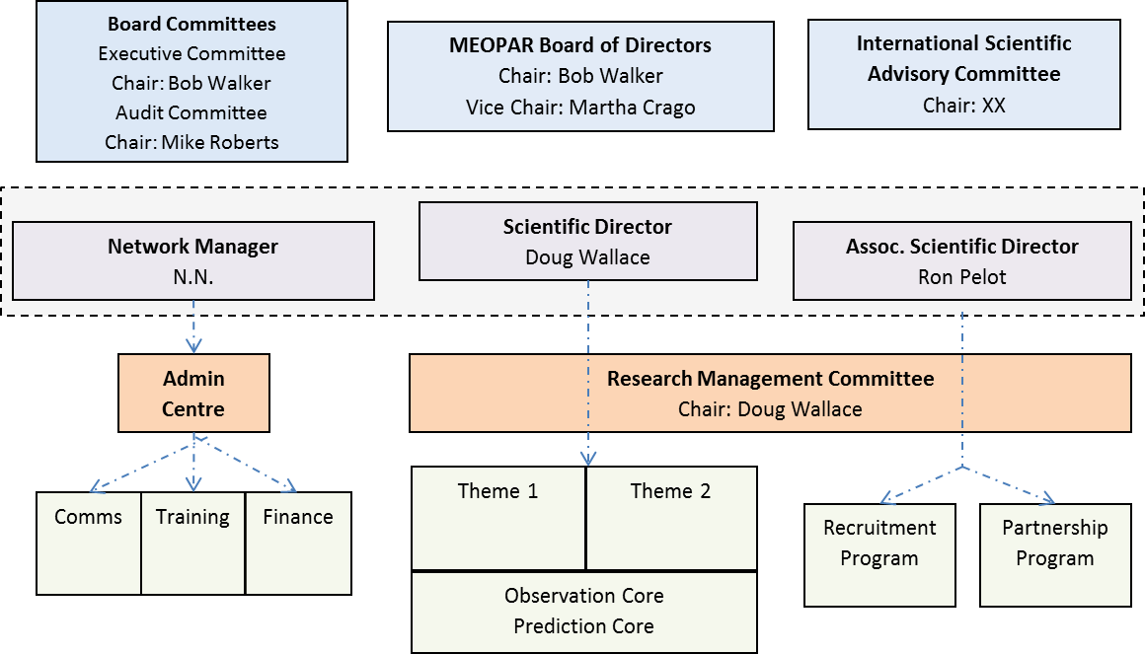
Figure S4. Organizational Structure of MEOPAR
MEOPAR’s governance structure is illustrated in Figure S4, with the committee mandates as follows:
The Board of Directors (or “Board”) is responsible for the overall governance of the network and acts in accordance with the By-Laws of MEOPAR Inc. The Board of Directors is accountable to the members and is responsible for steering and overseeing the activities and affairs of the corporation. The directors are elected by the members, and the members are appointed by resolution of the Board. The Board provides the strategic guidance for MEOPAR Inc. and approves the Network’s strategic plan and policies and procedures. Subcommittees of the Board of Directors include the Executive Committee and the Audit Committee.

The Executive Committee is an advisory committee to the MEOPAR management and Board on MEOPAR management issues. The Executive Committee is expected to perform the following roles or as additionally directed by the Board:
- Coordinate and make recommendations to the Board on Strategic Directions and coordination of the annual business cycle;
- Assess and advise the Board on matters of governance of MEOPAR Inc.;
- Recommend to the Board nominations for MEOPAR management if and when required;
- Action matters on behalf of the Board pertaining to resolution of conflict consistent with MEOPAR Inc.’s by-laws and corporate policies;
- Provide oversight on behalf of the Board MEOPAR Inc. human resources policies and management.

The Audit Committee is an advisory committee to the MEOPAR management and Board on audit and financial management issues. The Audit Committee is expected to take on the following roles when recommendations are necessary to the Board:
- Review MEOPAR corporate services and policies and make recommendations to the Board for approval;
- Review the MEOPAR audit report, management budget, and financial statements;
- Conduct an appointment review for the MEOPAR auditor, banker, and financial advisor (if any);
- Review the MEOPAR investment policy.

The Research Management Committee (RMC) has key responsibility for ongoing assessment of the research projects, setting of research priorities and recommending budget allocations, and will make recommendations concerning performance to the Scientific Director who, in turn, will present them to the Board. Through annual review of the scientific progress reports submitted by Projects and Cores, the RMC will monitor the progress of the funded projects in terms of their scientific advances and outcomes in training, Knowledge Transfer, Exchange and Exploitation (KTEE), Commercialization and Networking. The RMC may make specific recommendations regarding project performance, with possible adjustments made to funding for the following year.

International Scientific Advisory Committee (ISAC): To ensure transparency and an arm’s length approach in project review and selection, an International Scientific Advisory Committee (ISAC) will review project selection and review criteria, perform an annual assessment of the research program, and advise on the review of Open Call proposals. The ISAC will be composed of internationally recognized researchers and will provide strategic “Anticipation” advice on the scientific directions that will ensure MEOPAR achieves its long term objectives of excellence and leadership in marine prediction and risk analysis. The ISAC will provide advice to the Board concerning research priorities and proposed topics for the Open Call competitions to ensure they fit within the strategic aims of the Network. The ISAC will meet once per year with the Research Management Committee, usually in conjunction with the Annual Science Meeting. Membership on this Committee will include international experts in relevant fields including atmospheric and ocean prediction, climate change, socioeconomic impacts of climate change, risk and loss prevention. The ISAC members will appoint their own chair who will hold the position for an 18-month period (to cover one Open Call), subject to review by the Board.

