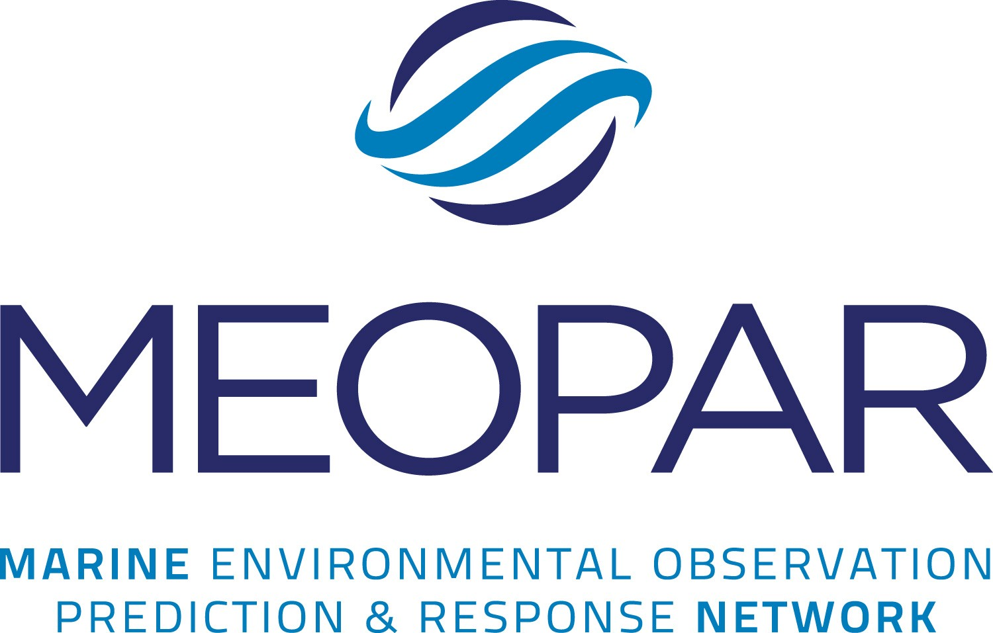

Call for Proposals

Early-Career Faculty Development Grants

Call for Proposals

2014

The Early-Career Faculty to be funded under this Call for Proposals will help build Canada’s capacity to anticipate and respond to marine environmental risk and strengthen the Marine Environmental Observation Prediction and Response (MEOPAR) network’s ability to address its strategic research objectives and goals.

- Aims
The Early-Career Faculty Development Grant program has four complementary aims:
- to provide a unique opportunity for Early-Career faculty to contribute to and participate in MEOPAR’s broad interdisciplinary, multi-institutional research effort thereby growing and extending their network of collaborators and interactions with stakeholders;
- to strengthen Canada’s ability and expertise with respect to anticipation and preparation for marine environmental risk of the future;
- to increase the participation of interdisciplinary, social science and health researchers in the MEOPAR network;
- to further integrate social science, health and natural science elements throughout the MEOPAR network.

- About MEOPAR

Established in 2012, the Marine Environmental Observation Prediction and Response Network of Centres of Excellence (MEOPAR) is building partnerships and a team of Canadian researchers to address critical issues related to human activity in the marine environment, and the impact of marine hazards on human activities in coastal regions.

MEOPAR’s vision is to inspire and enable Canadian leadership in marine environmental observation, prediction and response. MEOPAR delivers knowledge, technology, and people to enable Canada’s communities and industry to enhance resilience and economic opportunity through an informed relationship with the changing marine environment. Information on MEOPAR’s strategic goals are appended to this document and are available online at www.meopar.ca.

- Project Duration and Funding Levels
Under the Early-Career Faculty Development Grants Call for Proposals 2014, MEOPAR will support 2-year research activities starting in January 2015. This Call has a $1.2 million budget and will fund awards of up to $100,000 each – with the expectation that approximately half of the budget will be allocated in each of the two calendar years (2015 & 2016).

- Research Areas and Topics

MEOPAR encourages proposals addressing a wide variety of topics related to its research mandate. However, projects that address social science, policy, and/or economics topics that are closely aligned with MEOPAR’s strategic plan and research focus on marine risk and response will be given priority. The aim is to strengthen MEOPAR’s role in these areas and enhance the connectivity and integration of social science, health research and natural science.

Applicants are encouraged strongly to establish links with existing MEOPAR projects and activities. This may be through a formal cooperation with an existing MEOPAR research project, or through a clear explanation of how a distinct research focus is relevant to, and might be integrated with, other MEOPAR research.

Descriptions of existing projects are available through our website at http://meopar.ca, however proponents are encouraged to contact MEOPAR’s Executive Director, Neil Gall (902-494-4384, email: neil.gall@meopar.ca), to obtain more details and discuss how your interests align with current projects.

Eligibility and Collaboration

These grants are specifically aimed at university faculty members in the early stages of their academic career. Only one application per investigator will be considered. Eligibility is as follows (adapted from NSERC):

- You must hold, or have accepted, a firm offer of, an academic appointment at an eligible Canadian university at the time of application. For the duration of the award, you must hold such a position. The appointment can be:
  - a tenure-track position; or
  - a term or contract position of no less than three years.

- The position must allow you to engage in research that is not under the direction of another individual and must authorize you to supervise or co-supervise the research of students registered in an undergraduate or graduate degree program, and/or postdoctoral fellows (e.g., thesis supervision and not supervision of regular course or laboratory assignments).

- Adjunct professors are not eligible to apply for these grants.

- Existing MEOPAR project lead investigators are not eligible to apply for these grants. (Network investigators who are not project leads may be eligible. Please contact MEOPAR if you require clarification).

- At the time of the initial funding of your award (January 2015), you must be within five (5) years of your first (lifetime) academic appointment at a University or College and normally within ten (10) years of receiving your PhD.

- Your appointment must be ratified by the person(s) or body responsible for approving appointments or their delegate(s), and must be in accordance with university or college statutes.

- The source of salary funding for your appointment must be guaranteed for at least three continuous years within the period of the contract.

- Your faculty appointment must not be conditional on obtaining the MEOPAR grant or other sources of support.

- Before any funds can be released on a MEOPAR grant, the applicant must have taken up their faculty position and completed all degree requirements. For Early-Career Faculty Development Grants, this can be no later than the end of January 2015.

The Early-Career Faculty Development program provides individual research grants; therefore there must be only one Principal Investigator on the application. However, the applicant is encouraged to involve collaborators in their planned research. A collaborator is a researcher from any sector, e.g., government scientist, academic researcher, company staff member, who can be formally associated with the applicant, but who will not have access to MEOPAR grant funds. A collaborator must be qualified to undertake research independently and will be expected to contribute to the overall intellectual direction of the research and bring his/her own resources to the collaboration (text adapted from NSERC).

Other types of engagement are encouraged. Aside from the links with existing MEOPAR projects described earlier, research may also involve stakeholders from multiple sectors (i.e. academia, private sector, government, NGOs) in various roles such as participating in research definition, providing data, participating as subjects in the research and/or as end-users for the project outcomes. MEOPAR encourages proposals that include end-user involvement in the identification of the research topic to be addressed and the formulation, support and conduct of the research itself. Possible “end-users” could include, but are not limited to: the marine transportation industry, professional fish harvesters, offshore oil and gas operators, coastal communities, environmental organizations, all levels of government, ocean technology companies, and others. Support from external partners (in-kind and/or cash) is beneficial, but is not a requirement for the proposal. Proposals should clearly explain the nature of the participation and any commitments. Commitments from partners can include either direct support such as cash or in-kind support such as personnel time, use of equipment etc.

- Procedure
Applicants should consult MEOPAR’s Strategic Plan and Research Plan, both of which are available online at www.meopar.ca.

The proposal can be a maximum of 11 pages long, excluding CV, single-spaced (no more than six lines per inch), regular 12-point font, with margins of 0.75”.

The Proposal must follow the following format:

  - Cover Page (1 page maximum)
    - Title and contact information for Principal Investigator;

Summary (on 1 separate page but with 500 word maximum)
    - The summary is intended to explain the proposal in language that the public can understand. Using simple terms, briefly describe the nature of the work to be done. Indicate why and to whom the research is important, the anticipated outcomes and how your field, MEOPAR and Canada will benefit. This plain language summary will be available to the public if your proposal is funded;

Alignment with MEOPAR Strategic Objectives (1/2 page maximum)
    - Specific contributions of your research to MEOPAR’s Vision and connection to MEOPAR’s Strategic Goals & Objectives;

Research Plan, Approach & Outcomes (3 pages maximum)
    - Problem(s) to be addressed, including overview of the state‐of‐the‐art;
    - Objectives and/or outcomes of the research;
    - Timeline or Gantt chart;
    - Connections and perspectives (i.e. connections to other ongoing research activities, proposals, future perspectives beyond lifetime of the award, if any);

Multi-sectoral Structure and Support ( 1 page maximum)
    - Linkages to other MEOPAR activities and/or other existing projects or an explanation of how the research focus is relevant to, and might be integrated with, other MEOPAR activities;
    - End-user involvement;
    - Partnerships (academic collaborators, business, government, non- governmental organizations);

HQP Focus (1/2 page maximum)
    - Description of the number of highly-qualified people (HQP) to be engaged in the project. MEOPAR defines HQP as those still engaged in their education: undergraduate students, Masters students, doctoral candidates and post-doctoral fellows. Personnel costs for technical staff and research associates are also eligible costs but preference is given to HQP;

Budget Justification (1 page maximum)
    - Detailed budget (by year) according to Table 1 below;
    - Budget notes and justification;

References (1 page maximum)
    - Academic citations;

Letters of Support (2 pages maximum)
    - Maximum of two 1-page letters of support from partner agencies or end-user groups;

  - Curriculum Vitae
    - Provide a copy of your current CV using one of the standard formats used by NSERC, SSHRC, CIHR or the Canadian Common CV tool.

F1. Notes to Procedure

F.1a HQP

Applicants should provide a description of the main focus of each supported HQP, and when possible, specific names of those to be engaged. As an NCE, MEOPAR is mandated to assist in the training and development of the next generation of Canadian researchers, educators, ocean business leaders and policy makers. As such, MEOPAR has initiated a training network for those HQP involved in MEOPAR-funded projects to give them professional development opportunities they would not normally receive from their program of study. MEOPAR’s definition of HQP includes undergraduate students, Masters students, PhD candidates and postdoctoral fellows. In addition to the training at the network level, each project is encouraged to provide creative training and professional development opportunities for their HQP, which can be described in the HQP section.

F.1b Budget

A detailed budget with specific breakdowns and justification for each category is required for the proposals. For example, in the “Personnel” section, please be specific about the number of people to be hired and their status (Masters student, PhD candidate, postdoctoral fellow, research associate etc.). If listing an “Equipment” category, please specify the type of equipment, approximate cost and rationale for purchase. If listing a “Travel” category, please include information such as the intended destinations and number of people traveling. Please differentiate between travel required for the research activity and travel related to knowledge mobilization (e.g. travel to conferences).

As stated previously, please indicate whether partner contributions are in the form of cash or in-kind. Typically, the budget should be split between the two years (i.e. about $50,000 per year), and should not exceed $100,000 total funds requested from MEOPAR. The budget table should follow this format:

Table 1: Project Budget
Category | Year 1 | Year 2 | Totals
Personnel
Materials, Supplies, Dissemination
Travel
Equipment
Totals
Partner cash expected
Partner in-kind requested
MEOPAR funds requested

F.1c Letters of Support

Separate letters of support from external partners (specifically those offering cash and/or in-kind contributions) can be included with the proposal. A maximum of 2 letters of support, with each letter being 1 page in length, will be accepted.

G. Submission

Your application must be received by MEOPAR by 9:00 p.m. (Atlantic Time) on November 7, 2014. If not received by MEOPAR by that time and date, your application will be considered late and will be rejected. Applications must be submitted electronically in PDF format to Janet Marshall, Executive Assistant, at janet.marshall@meopar.ca.

The Corporate Centre of MEOPAR will receive proposals and provide an initial compliance screening. Proposals that do not follow these requirements explicitly will be returned to the applicant(s) and given one 24-hour period to comply and resubmit. Proposals that still do not comply with these criteria will be removed from the competition and will not be considered.

H. Evaluation
Proposals will be reviewed and assessed by MEOPAR’s Research Management Committee (RMC) and additional outside, expert reviewers as needed. The RMC’s recommendations on the Proposals will be forwarded to MEOPAR’s Board of Directors for approval in December 2014. Financial awards will be in place by the end of January 2015, contingent on signing of Network Agreements.

The criteria for the review of the Proposals will be:

1 | Alignment with MEOPAR Objectives
1.1 | MEOPAR Strategic Goals
 | The proposed project research activity must link strongly and convincingly to MEOPAR's goals and objectives as listed in appendix I.
1.2 | End-User Involvement
 | End-user involvement in the proposed research and in the formulation of research questions/topics is encouraged.
2 | Researcher Excellence
2.1 | Excellence of the Researcher
 | The accomplishments and potential of the applicant must be of high quality, impact and relevance.
2.2 | Area of Focus
 | Priority will be given to applicants with a background in relevant areas of health, social science or interdisciplinary research.
2.3 | Interdisciplinary Excellence
 | Applicants with previous experience in interdisciplinary research and/or collaborations are encouraged.
2.4 | Experience Engaging End Users
 | Priority will be given to applicants with demonstrated experience with end-user engagement. End-users can be defined as government, industry or other stakeholders external to academia.
3 | External Linkages and Support
3.1 | Builds on Existing MEOPAR Initiatives
 | The proposal should demonstrate convincing integration with, and/or extension of, existing MEOPAR projects or provide a clear explanation of how the research focus is relevant to, and might be integrated with, other MEOPAR research.
3.2 | Builds on Other Relevant Initiatives
 | Consideration will be given if applicants demonstrate convincing integration with, and/or extension of, other existing national or international initiatives.
3.3 | Leverage
 | Consideration will be given to proposals that demonstrate quantifiable cash and/or in‐kind contributions from external sources. NSERC guidelines should be followed for the valuation of in‐kind contributions.
4 | Merit of the Proposal
4.1 | Innovation / Originality
 | The proposed project must be highly innovative and have the potential to produce significant advances.
4.2 | Interdisciplinary Research Focus
 | The proposed project must contain convincing integration of research activities of at least two of: natural sciences, social sciences and health research.
4.3 | Project Feasibility
 | The proposed objectives, milestones, research methodology and budget must be clear and realistic.
5 | Training of Highly Qualified People (HQP)
5.1 | Participation of HQP
 | The proposed project should have a clear plan for the involvement of, and well‐defined responsibilities and opportunities for, the integration of HQP.

Questions about MEOPAR’s Early-Career Faculty Development Grants can be referred to:

Mr. Neil Gall
Executive Director, MEOPAR 1355 Oxford Street, Suite 2-41 Halifax, NS, B3H 4J1
(t) 902.494.4384
(e) neil.gall@meopar.ca

Appendix – MEOPAR’s Strategic Goals

MEOPAR's seven goals, through which it delivers on its long-term 15-year vision are:

An operational network: Promote an operational network for marine observation, prediction and response along Canada’s coastline through a cooperative approach linking government agencies, academia, municipalities, non-governmental organizations and ocean-related industries.

Information and knowledge exchange: Improve sharing of information and knowledge between communities, private and public sectors, non-governmental organizations, academia and government in order to improve response capability and resilience in the face of changing patterns of risk in the marine environment.

Northern hazard assessment: Provide scientific information and evaluation of marine hazards to guide economic and community development in Canada’s northern marine environment.

Private-sector participation: Strengthen Canadian private-sector expertise in marine environmental observation, prediction and response and promote this expertise to address national and international problems.

International cooperation: Promote international cooperation in marine environmental observation and prediction, including adoption and leverage of international best practices and expertise for the benefit of Canadians.

Fundamental research: Enhance resilience through development of new understanding of marine hazards and associated vulnerabilities, and improved ability to predict and project risk.

Economic opportunity: Create economic opportunity through enhancement of resilience as well as through commercialization and application of new approaches to marine observation and prediction.

The MEOPAR Network works closely with government agencies, industry and international partners to develop new mechanisms for the sharing of expertise, data, infrastructure, and approaches relevant to anticipating and responding effectively to marine emergencies. With a projected lifetime of up to 15 years, MEOPAR will have fundamental impacts on Canada’s preparedness in the face of marine hazards.

MEOPAR’s research program includes development and integration of science-based technologies and tools to improve Canada’s ability to respond to marine emergencies as they occur, and anticipate and adapt to changes to the risk of marine extremes and emergencies over the next century. Over its first five years, MEOPAR’s effort will focus on: a) establishment of new partnerships, working relationships and training programs;
b) demonstration of new cooperative approaches to observation, prediction and response, and c) organization of effective transfer of knowledge concerning marine hazards. Specifically for the first five-year phase of NCE support (2012-2017), the seven principal objectives are to:

- Establish the first nodes of a new pan-Canadian network of integrated observing and prediction systems for strategically important locations.

- Develop new tools and technologies for rapid environmental assessment and forecasting during marine environmental emergencies.

- Link projection of future changes in storms, coastal flooding, waves on local scales with consideration of economic impacts, safety, planning, and policy.

- Assess the impact of long term, oceanic change on Canadian coastal communities, ecosystems and economic interests, including implications for resource management, regulation and policy.

- Introduce new approaches for training of highly qualified personnel with skills in the natural and social sciences and their use in solving problems related to marine risk.

- Implement new approaches for sharing natural and social science expertise, data and infrastructure in order to respond more effectively to marine emergencies.

- Establish an “Expert Forum” involving Canadian and international experts, policymakers and stakeholders for the illumination, evaluation and communication of emerging and new risks in the marine environment.

In order to achieve these five-year objectives, MEOPAR’s research program presently comprises more than 20 projects. Projects are organized under two research themes:

Theme 1 aims to improve the ability of government and private sector to respond to existing and emerging marine hazards on time scales of hours to seasons.

Theme 2 aims to develop and test techniques aimed at improving the ability of government, the private sector, and coastal communities to anticipate, prepare and adapt to developing marine risks on time scales of seasons to a century.

The Network is also supported by a Prediction Core and an Observation Core. These provide crosscutting technical and scientific support across the projects.

