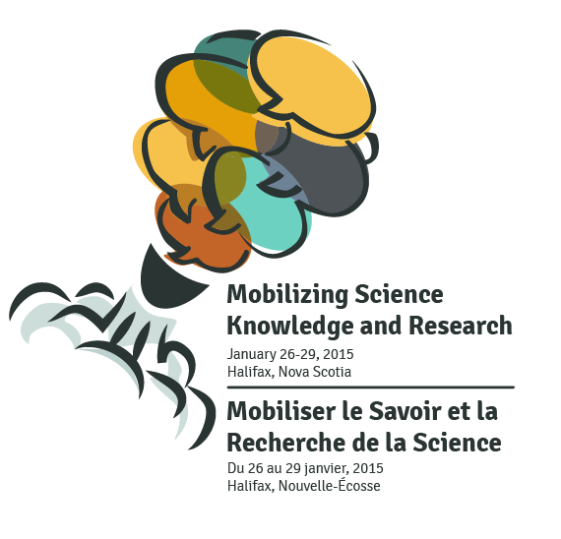

An NCE Sharing of Best Practices Symposium
Halifax Marriott Harbourfront Hotel
Note:
Symposium website: meopar.ca/sciencekmb2015; please check it and our Twitter feed (@meopar_nce) regularly for updates; tweet using #kmb2015

Registration update: We reached registration capacity! Thank you to everyone for registering! We look forward to welcoming you to the symposium.
If you require a dinner ticket, please purchase yours by noon Atlantic, Tuesday, January 20, 2015 via our Eventbrite site at http://www.eventbrite.ca/e/mobilizing-science-knowledge-and-research-in-the-21st-century-an-nce-sharing-of-best-practices-registration-13872245259
Symposium highlights:
* 10 KMB-related exhibits and 7 HQP science KMB posters
* 6 NCE KMB case studies, Wednesday & Thursday
* 9 KMB training workshops, Tuesday-Thursday
* Monday, January 26: Mobilizer Mixer
* Tuesday, January 27: keynote by MEOPAR researcher, Dr. Gordon McBean, President of the International Council for Science
* Wednesday, January 28:
1) Community Roundtable luncheon: Exchanging New Knowledge with Politicians and Decision Makers to Affect Success/Positive Change hosted by the Ocean Tracking Network
2) Symposium dinner: KMB ‘edutainment’ followed by guest speaker Dr. Robin Urquhart, knowledge translation physician scientist, Dalhousie University
* Thursday, January 29:
Community lunch and Canada Research Chair on the Transformations of Scholarly Communication
Dr. Vincent Larivière, Chairholder and Assistant Professor, Information Science, École de bibliothéconomie et des sciences de l'information, l’Université de Montréal

Symposium Schedule
subject to change/confirmation
as of January 16, 2015
Final program will be posted on the symposium website the week of January 19, 2015

All symposium events will occur on the Ground Floor of the venue hotel (see floor plan, page 5).

Monday, January 26, 2015 |  | Meeting room
1:15-4:30 p.m. | Exhibits and KMB Science poster setup; to remain for 3 days | Sable to Acadia Foyers
6:30-8:30 p.m. | Mobilizer Mixer (delegate reception) | Sable Foyer
Tuesday, January 27, 2015
Theme: | “From Science Research…”
8:00 a.m. | Continental breakfast/registration  *registration will conclude at 12 noon | Acadia ABC
9:00 a.m. | Welcome & Remarks:  Dr. Doug Wallace, MEOPAR Scientific Director & Canada Excellence Research Chair in Ocean Science and Technology  Sara Rezaee, PhD candidate/MEOPAR HQP | Sable ABCD
9:30 a.m. | Keynote: Dr. Gordon McBean, President, International Council for Science/MEOPAR Researcher | Sable ABCD
10:30 a.m. | Networking break/visit Exhibits and Science KMB posters | Sable to Acadia Foyers
11:00 a.m. | The Landscape/‘State of the Union’ of Science KMB in Canada: The NCE Secretariat Perspective  Rick Schwartzburg, Senior Program Manager,  NCE Secretariat | Sable ABCD
12:00 p.m. | Networking lunch | Sable ABCD
12:00 p.m. | Visit Exhibits and Science KMB posters | Sable to Acadia Foyers
1:00 - 4:30 p.m.  Note:  catering for the afternoon break will be provided outside the workshop rooms, in the Acadia Foyer, 2:30-3:00 p.m.; workshop leads will determine break time | Tools for Science KMB workshops
 | Mobilizing Science Knowledge and Research? There’s an App for that!  Andrew Hicks, Creative Producer, Fairfield Creative | Acadia A
 | An Entrepreneurial Approach to KMB: Not Just for Business!  Mary Kilfoil, Assistant Professor, Innovation and Entrepreneurship; Academic Lead, Starting Lean Initiative, Rowe School of Business, Faculty of Management, Dalhousie University | Acadia B
 | Write for the Reader: Writing Clear Language Research Summaries  Matthew Shulman, Executive Director, Peel-Halton-Dufferin Adult Learning Network | Acadia C
Wednesday, January 28, 2015 |  | Meeting room
Theme: | “…to New Knowledge…”
8:00 a.m. | Continental breakfast/registration  *registration will conclude at 12 noon  Video recap of day 1 will be played at 8:30 a.m. | Acadia ABC
9:00 a.m. | Welcome/day’s intro (NCE HQP)  Five Years Later: Knowledge Mobilization  GRAND NCE | Sable ABCD
9:45 a.m. | Mobilizing New Cybersecurity Knowledge  SERENE-RISC NCE | Sable ABCD
10:30 a.m. | Networking break/visit Exhibits and Science KMB posters | Sable to Acadia Foyers
11:00 a.m. | Co-Presentations:  1) Radiation Risk Communication to the Public  2) Knowledge Mobilization and Building a Citizen Scientist Monitoring Network for the InFORM Project: An Effort to Determine the Impact of the Fukushima Disaster on Canada’s Oceans and Residents  Health Canada and MEOPAR NCE | Sable ABCD
12:00 p.m. | Community Roundtable lunch: Exchanging New Science Knowledge and Research with Politicians and Decision Makers to Affect Success/Positive Change  Host: Nikki Beauchamp, Communications, Ocean Tracking Network | Sable ABCD
1:00 - 4:30 p.m.  Note:  catering for the afternoon break will be provided outside the workshop rooms, in the Acadia Foyer, 2:30-3:00 p.m.; workshop leads will determine break time | Where Art Meets Science (the intersection of) for KMB: Arts-based workshops
 | The Power of Graphic Recording for Science KMB  Corrie Melanson, SeeMeaning.ca | Acadia A
 | Moving Knowledge through Storytelling  Victoria Bryce, Project Manager/Administrator, Children and Youth in Challenging Contexts NCE | Acadia B
 | Use of Artistic Visualization to Mobilize Knowledge  Paul Maher, Part time faculty, Nova Scotia College of Art and Design University | Acadia C
6:30-8:30 p.m. | Symposium dinner (business casual dress) | Sable ABCD
6:30-8:30 p.m. | 6:30 p.m. Science KMB ‘edutainment’/reception | Sable ABCD
6:30-8:30 p.m. | 7:00 p.m. Welcome/introductions; dinner | Sable ABCD
6:30-8:30 p.m. | 7:45 p.m. Guest speaker: Dr. Robin Urquhart, Knowledge Translation Scientist/Assistant Professor, Department of Surgery, Dalhousie University | Sable ABCD
6:30-8:30 p.m. | 8:30 p.m. Closing remarks | Sable ABCD
Thursday, January 29, 2015 |  | Meeting room
Theme: | “…to Impact.”
8:00 a.m. | Full hot breakfast  Video recap of Day 2 will be played at 8:30 a.m. | Acadia ABC
9:00 a.m. | Welcome/day’s intro (NCE HQP)  The Story of TREKK: TREKK NCE | Sable ABCD
9:45 a.m. | PREVNet’s Model of Co-Produced Pathway to Impact:  PREVNet NCE | Sable ABCD
10:30 a.m. | Networking break/visit Exhibits and Science KMB posters | Sable to Acadia Foyers
11:00 a.m. | Development of Indicators for Measurement at Each Stage of Knowledge Translation from Research to Impact  NeuroDevNET NCE | Sable ABCD
12:00 p.m. | Community lunch and Canada Research Chair on the Transformations of Scholarly Communication  Dr. Vincent Larivière, Chairholder and Assistant Professor, Information Science, École de bibliothéconomie et des sciences de l'information, l’Université de Montréal | Sable ABCD
1:00 –  4:15 p.m.  Note:  catering for the afternoon break will be provided outside the workshop rooms, in the Acadia Foyer, 2:30-3:00 p.m.; workshop leads will determine break time | Influencing and Transforming Policy through KMB for Stakeholders  (concurrent workshops)
 | Recipe Ideas for a Cake You Can Have and Eat: How You Can Use Citizen Science to do Research AND Knowledge Mobilization  Dr. Yolanda Wiersma, Associate Professor, and Emma LeClerc, M.A. candidate, Memorial University | Acadia A
 | Adapting to Climate Change: Local Governance, Policy and Planning in Nova Scotia Municipalities  Brennan Vogel, PhD candidate, University of Western Ontario/MEOPAR HQP | Acadia B
 | Lessons in Knowledge Mobilization from Memorial University: Public Engagement, The Harris Centre and Yaffle  Dr. Rob Greenwood, Executive Director, Public Engagement and the Leslie Harris Centre of Regional Policy and Development, Memorial University | Acadia C
4:30 p.m. | Closing remarks/Evaluation  Exhibits and science KMB posters dismantling | Acadia ABC

Note:
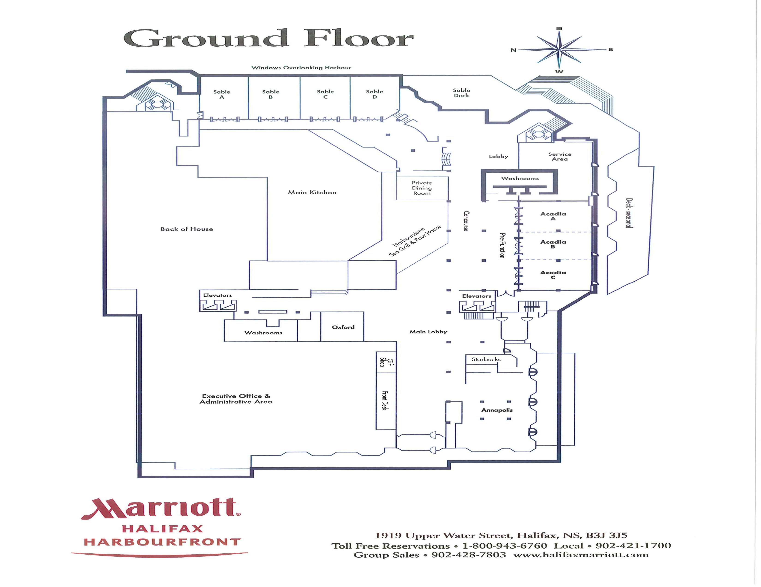
At 4:20 p.m., the hotel staff will open the divider walls between Acadia A, B & C to create one main meeting room for the symposium closing.

