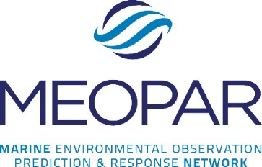
Mobilizing Science Knowledge and Research in the 21st Century:
An NCE Sharing of Best Practices Symposium
Halifax, Nova Scotia
January 27-29, 2015
Session/Scientific Poster Proposal
The symposium is a knowledge mobilization training and education initiative by MEOPAR in collaboration with other NCE partners, for our respective researchers, HQP's, knowledge mobilization practitioners, scholars, science researchers, science industry partners, and stakeholders, to name a few. We believe the symposium will be the first of its kind: a Canadian science-focused KMB initiative for the NCE's since the program was established in 1989.

Session Proposals
We invite submissions for six NCE session proposals, for Wednesday or Thursday of the symposium, in English or French: two sessions each day are each 45 minutes in length and one session each day is one hour in length. Proposals will be accepted from any NCE-affiliated researcher, HQP, or staff person. Proposals that reflect a team approach to knowledge mobilization (e.g., researcher, HQP, staff, and stakeholder) are encouraged. The symposium is a training opportunity, so we encourage you to identify an HQP from your NCE who will be the session moderator; this information is requested in your proposal submission.

Scientific Posters
We invite submissions for 20 knowledge mobilization-related scientific posters, in English or French, from NCE HQP’s only.

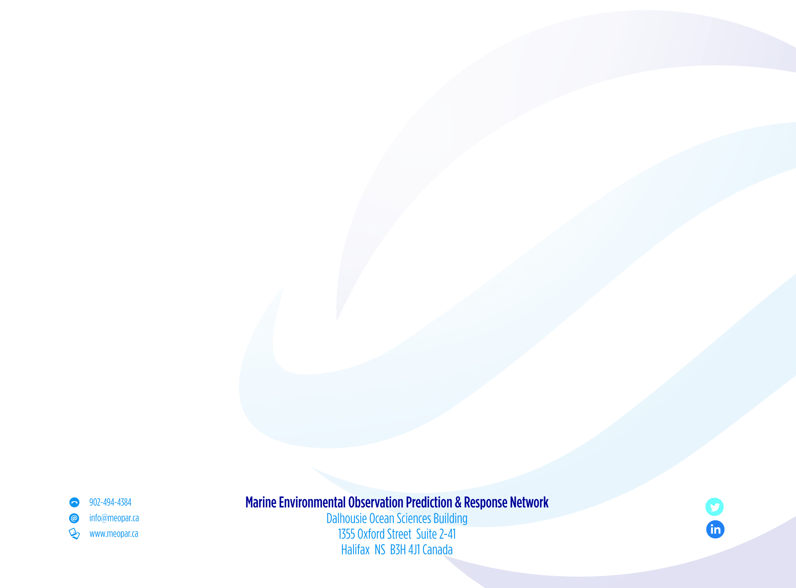
If you wish to submit a session proposal and/or a scientific poster, please complete this proposal application and submit it by 4 p.m. Atlantic, Monday, December 15 via email to kmb2015@meopar.ca. All proposals will be responded to by 4 p.m. Atlantic, Friday, December 19. Incomplete submissions will not be considered nor returned to the submitter for completion.

Is this proposal for a session or a scientific KMB poster?
If for a session, please complete Section A; if for a scientific KMB poster, please complete Section B. (An applicant may submit a session and poster proposal).

Section A (Session proposal—open to all applicants)
Proposal submitted by:
Name:
Title:
University/organization:
Department:
Email:
Phone:
Are you affiliated with an NCE?
If yes, which one?

Are you a:
NCE funded investigator
HQP
Staff
Other (please specify):

Session title:
Session description:
Session format (e.g., panel, lecture, workshop, etc.):
Under which day’s theme is your proposal applicable?
Wednesday (“…to new knowledge…”)
Thursday (“…to impact…”)
Which session timeslot do you prefer?: 45 minutes or one hour
Will the session be in English or French?
HQP moderator:

Speaker information
For each of the session’s prospective speaker(s) and HQP, please include:
-his/her biography
-title
-email address
-funded NCE investigator, HQP or other?
-.jpg photo (2” x 3”)
What supplies, multi-media equipment, etc. will you require?
laptop computer?
MAC or PC?
data projector?
Other (please specify):

Comments
Please use this space to advise us of anything relevant to your submission:

Section B (Scientific KMB poster proposal [NCE HQP applicants only])
Author(s) name(s):
University/organization:
Department:
Email:
Phone:
Which NCE are you affiliated?
Scientific KMB poster title:
Poster description:
Poster size:
Is your poster:
portrait or landscape in orientation?
laminated?
pre-mounted?

If your scientific KMB poster is accepted for the symposium, setup will be at the venue hotel, Monday, January 26, 2015, anytime between 1:15-4:30 p.m. Removal of posters will be 3-4 p.m., Thursday, January 29, 2015.

Comments
Please use this space to advise us of anything relevant to your submission:

