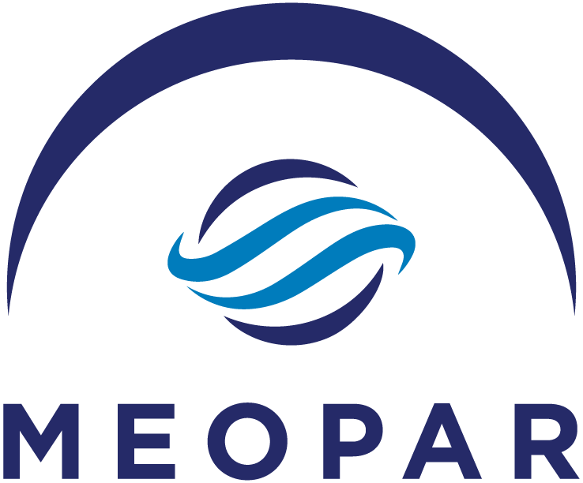

Knowledge Mobilization Fund

Purpose:
MEOPAR’s Knowledge Mobilization (KM) Fund supports efforts by current and former MEOPAR investigators to think beyond the academic sector in communicating about their research. This fund complements MEOPAR’s suite of funding opportunities for research, communities of practice and training.

The KM Fund will support high-impact knowledge mobilization and dissemination activities from within the MEOPAR network. This may include specialized websites, graphic visualizations, public materials, commercialization and incubator activities, and other innovative approaches to engaging with the research process. Preference will be given to ideas that spark the imagination, reaching non-academic audiences in creative and purposeful ways.

Who Can Apply?

The KM Fund supports the mobilization of MEOPAR research projects. Applicants should be current or former principal investigators of MEOPAR projects, OR endorsed (via letter of support) by a MEOPAR PI to apply.

If the KM Fund budget is not fully allocated, the committee may consider applications from outside of the network that fit within MEOPAR’s strategic plan. If submitting from outside the network, please indicate clearly how your proposal fits within MEOPAR’s subject area, and how it would contribute to the mobilization of MEOPAR-related research.

Audiences:

The KM Fund supports interaction with non-academic audiences. This includes policy-makers, decision-makers and leaders, industry, not-for-profits, and the general public. Your proposal should clearly articulate why you selected the key audience group, how the idea will improve knowledge mobilization, and why that approach is the best way to reach that audience. The KM Fund is not to be used for academic workshops, researcher networking, or training opportunities.

If your idea convenes researchers together for the purpose of networking, improving collaboration or building project teams, please apply for the Investigator Networking Fund.

If you are leading or participating in the administration of a MEOPAR community of practice, please apply to the Community of Practice fund.

If your idea involves training and professional development, please review the funding opportunities in the Training Program.

Types of Ideas:

The following are examples of types of activities that could fit under the KM Fund. The list is not all-encompassing; for questions about your activity and the suitability to the KM Fund, please contact Heather Desserud (heather.desserud@meopar.ca).

- Market validation, patent applications and business planning
- Matching funding for incubator, accelerator or commercialization programs
- Website development and content
- Video production and photography
- Data visualization
- Translation into a key audience language (e.g. Inuktitut)
- Marketing materials and collateral (brochures, posters, one-pagers, banners)
- Public/non-academic workshops and events
- Social media planning
- Production of policy briefs, support materials and other policy-focused activities.

Please note: this fund is not designed to support new research activities.

Funding Process:

Depending upon the type of idea proposed, funding will either be disbursed to a university research account via award letter, or through direct payment to contractors for communication/marketing expenses. Please review Dalhousie’s procurement policies, and include any quotes you have obtained if relevant when submitting your budget.

The total funding budget for this fund in 2019-2020 is $100,000. Individual applications should generally fall within the $5,000-15,000 range, and should include expenses that will be incurred before March 31, 2020.

Exceptional, high-impact ideas with a higher budget will be considered on a case by case basis. Applicants may be contacted for further proposal development after submission.

Deadlines:

The KM Fund is open for applications from July 9 until September 30, 2019. Applications may be reviewed earlier as needed; please indicate time constraints clearly in your application.

A second round of funding may be released in 2020, depending upon the success of this year’s funding round.
Application Form: Knowledge Mobilization Fund

Contact Information for Applicant
Name:
Job Title/Position:
Institution:
E-mail:
Phone:

Please include any relevant letters of support, supplier quotes or other information that strengthens your proposal.

- Describe the type and scope of the proposed KM idea, including the audience it will reach. (max 250 words)

- Explain why you selected the key audience, how the idea will improve your project’s knowledge mobilization, and why this is the best approach to reach that audience. (max 500 words)

- Describe the expected output/s of the proposed idea, and what steps have been taken to find suppliers, research other examples or identify gaps. (max 250 words)

- How does this idea go above and beyond standard project dissemination activity? (max 250 words)

- Budget – Please attach a detailed budget table, and include any budget justifications required, including any cash or in-kind contributions from other sources (existing MEOPAR funding can’t be used as in-kind). (max 250 words)

