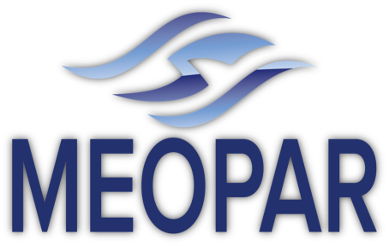

Marine Environmental, Observation, Prediction and Response Network

MEOPeer Researcher Development Sponsorship 2014/15
Application
Name:

Position:

Institution:

Email:

Phone:

Project supervisor:
Event (please provide url if available):

Event date(s):

Event location:
Estimated expenses (maximum of $2500; please list with estimated amounts for each):

Applicant: Please explain how attending the event for which you seek sponsorship directly relates to and will benefit your research, academics and/or career:

Project Supervisor: Please describe how the research project will benefit from the HQP’s participation at this event (e.g., expected outcomes to be applied, etc.):

Supervisor signature: Date:

Applicant signature: Date:

