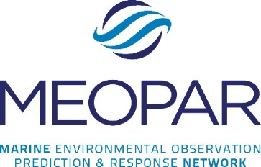
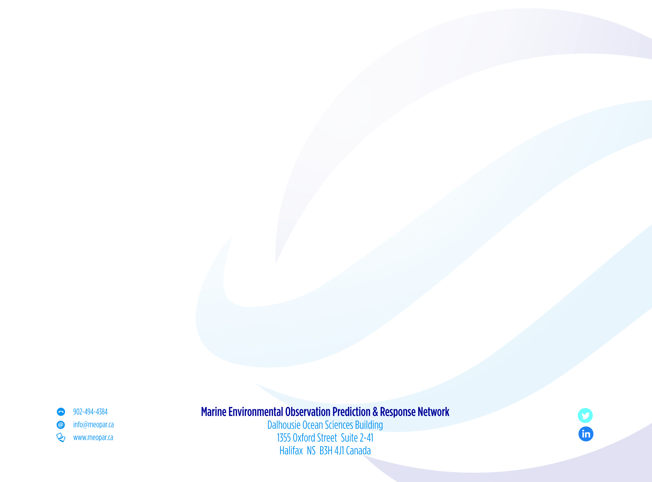
HQP (MEOPeer) Researcher Development Sponsorship 2015/16
Information and Application
Introduction/Purpose
In recognition of the uniqueness of the MEOPAR funded research projects, and that the project’s HQP's may have similarly unique individual training needs that the MEOPeer training program may not address, MEOPAR allocates $25K of its training budget/fiscal year to support the academic, research and/or career development needs of the MEOPeer researchers (10/fiscal year). The sponsorship is a maximum of $2500/HQP for one event/fiscal year and is to be used to pay the training-related expenses of the HQP to participate in a researcher development event in the same fiscal year. This sponsorship is to provide financial support to the HQP for researcher development-related expenses unique to the project that are not provided for by the project's respective budget. If the applicant is uncertain, please confirm this with the project supervisor before applying. The sponsorship fund will be reviewed at the end of each fiscal for consideration into the next fiscal, funds permitting.
Eligibility/Application
Any HQP hired by a MEOPAR funded project is eligible to apply for sponsorship (next page). Given the large number of MEOPeers in the network, and to ensure fair access to this fund by all HQP’s, only one sponsorship will be awarded/MEOPeer. The MEOPAR Training and Research Co-ordinator will facilitate the sponsorship program. The researcher development opportunity must occur in the same fiscal year in which the application is received; one cannot apply for sponsorship in one fiscal year for an opportunity in the next fiscal year. Applications that reflect collaboration for a training opportunity by a group of MEOPeers are strongly encouraged; for example, a MEOPeer group proposal to lead a workshop is accepted. Applications can be submitted anytime; please complete and submit the application to MEOPAR at least one month (preferably 3 months) prior to the development opportunity.

Review and notification process
The MEOPAR Scientific Director (SD), Associate Scientific Director (ASD) and Executive Director (ED) will review all applications. Should an HQP be a hire of the SD or the ASD, an alternate reviewer will be sought. Applicants and their supervisors will be notified of the review outcome by email from MEOPAR as early as possible.
Expense claim
The HQP must submit a travel claim for approval and reimbursement of expenses (to a maximum of $2500) within 30 days of participation to MEOPAR. Once approved, the travel claim will be forwarded to Financial Services at Dalhousie University for processing which can take up to 3 weeks. The travel claim form and instructions for completion can be read here.

Return on investment
By accepting sponsorship, the HQP agrees to disseminate the new knowledge, skills, resources, information, etc. acquired from the development opportunity to his/her MEOPeers in the same fiscal year. The logistics for this will be co-ordinated between the applicant and MEOPAR.

HQP (MEOPeer) Researcher Development Sponsorship 2015/16
Application
Name:

Position:

Institution:

Email:

Phone:

Project supervisor:

Event Name/Title (please provide url if available):

Event date(s):

Event location:
Estimated expenses (maximum of $2500; please list with estimated amounts for each):

Applicant: Please explain how participating in the event for which you seek sponsorship directly relates to and will benefit your research, academics and/or career:

Project Supervisor: Please describe how your research project will benefit from your HQP’s participation at this event (e.g., expected outcomes to be applied, etc.):

Supervisor signature: Date:

Applicant signature: Date:

Contact/Questions?
Please forward applications and/or direct any questions to Tanya Crawford, Training and Research
Co-ordinator, MEOPAR, (902) 494-4385.

