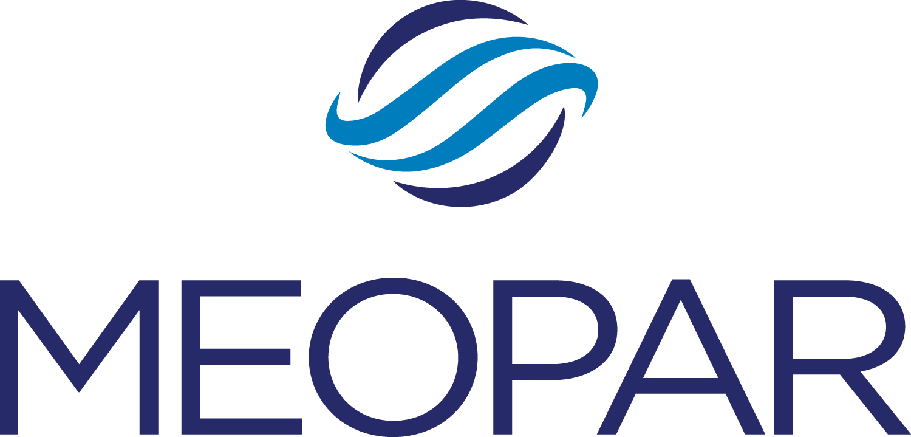

Mentee Application Form
Career Mentoring Program Information

MEOPAR’s Career Mentoring Program matches Highly Qualified Personnel (HQP) with mentors who are professionals working in the field of marine risk and resilience. The program is modeled after the University of Alberta's Graduate Student Career Mentoring Program (GSCMP).

Mentors will provide their mentees with advice, support and strategies that will promote progress and success in the mentees' future careers. In turn, mentees will work to achieve their goals in a low-risk environment under the guidance of their mentor.

The Career Mentoring Program is open to all HQP. The program commitment for both mentors and mentees is a minimum of one hour per month for six months. Mentee applications are due September 15, 2017. Mentees will be matched with mentors in October.

Applicant Information

Name:

Position/Level of Study:

Institution:

Your City & Province:

Email:

Phone: ( ) -

Project Information

MEOPAR Project Name:

Project Supervisor:

Project Principal Investigator (PI):

- Please explain why you are interested in being matched with a mentor.

- What knowledge, skills, or connections would you like your mentor to help you develop?

- What are your career aspirations? If you’re exploring your options, what are some career paths you are considering, or what types of work have you enjoyed in the past?

- What area/field and organization would you like your mentor to be working in? What areas of expertise would you like them to have?

Do some research on LinkedIn and provide specific organization/company names and job titles, so we can find the best mentor for you.

Applicant signature: Date:

Contact/Questions:
Please email applications to Laura Avery, Training Program Coordinator, by September 15, 2017.

