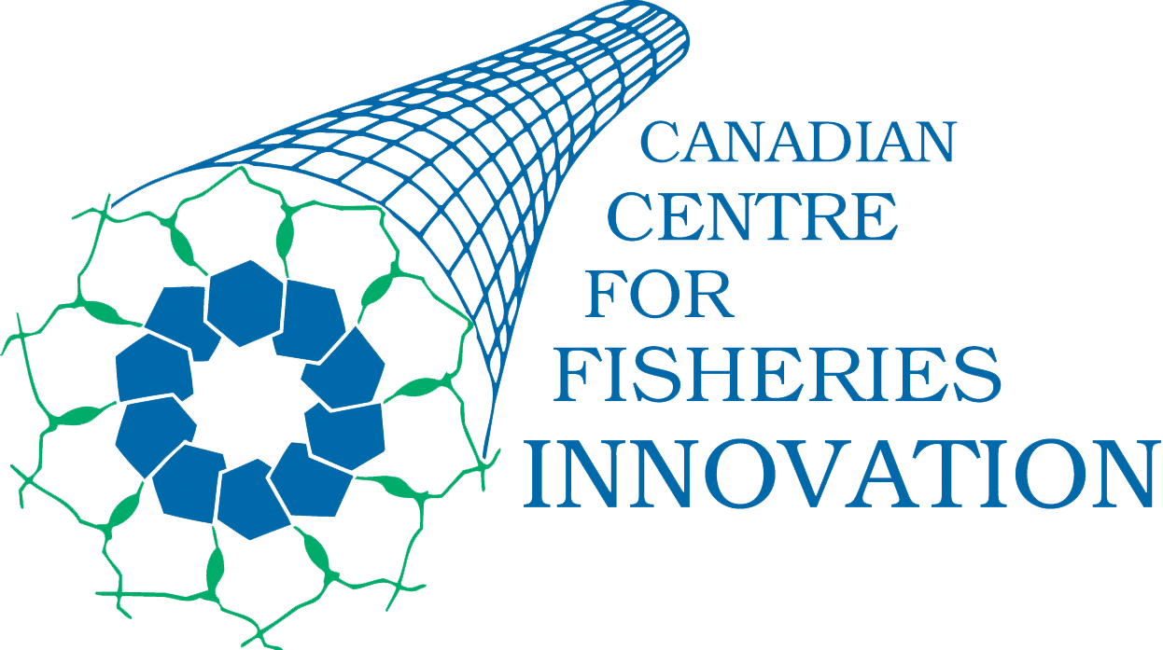
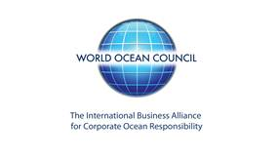

WORKSHOP
Smart Fishing Vessels: Ocean and Atmospheric Observations by Industry

Hosted by the World Ocean Council and the Canadian Centre for Fisheries Innovation
In Association With The World Seafood Congress

29 September, 2013
Delta Hotel, New Gower Street, St. John’s, NL
St. John’s, Newfoundland

Number of Attendees: 32

I. WORKSHOP GOALS
- Create a broad, multi-stakeholder community on fisheries industry data gathering and the experience to date.
- Develop a common understanding of the opportunities and associated constraints for expanding use of fishing vessels in data collection.
- Facilitate fishing industry opportunities to share, learn from and collaborate with other ocean industries in collecting and sharing data.
- Develop shared information on the technology and instrumentation available for use on fishing vessels.
- Identify the priorities and quality assurance and control for fishing industry data collection.

II. SUMMARY

1. Introduction to World Ocean Council and WOC Smart Oceans/Smart Industries Program
Leslie-Ann McGee
Global program for facilitating and coordinating efforts to scale-up data collection and sharing by diverse ocean users, e.g. fisheries, shipping, oil/gas, offshore renewables, aquaculture and others.
(Presentation Attached)

2. Introduction to the Canadian Centre for Fisheries Innovation and FishSmart Program
Bob Verge, Canadian Centre for Fisheries Innovation
The reality and key challenges and experience of data collection from fishing vessels.
(Presentation Attached)

3. Data Users / Data Providers Panel

Questions Posed to Panelists:
DATA USERS AND TECHNOLOGY
- Who are potential users of the data?
- What scientific and operational questions need to be addressed?
- Are there different data needs for marine operations and for science?
- How can data quality assurance, control and interoperability concerns be addressed?
- How can the data collected be optimized for the different user groups?

DATA COLLECTORS/PROVIDERS
- Are vessel operators willing to participate, what is the value proposition?
- What are the priority parameters and locations for data gathering from fishing vessels?
- What parameters are now measured and reported?
- What kinds of instrumentation and technology have been used?
- What have been the successes and failures in data collection and sharing?
- What are the opportunities and barriers to scaling up data collection and sharing?
- What technology is needed and how can it be provided?
- What are the needs and opportunities for financing data collection?

Randy Gillespie, Centre for Applied Ocean Technology, Fisheries and Marine Institute
We have been talking to fishermen about being collectors of data, not just collectors of fish for almost 10 years. Over that time fishermen have consistently indicated a willingness to get involved. For them the value proposition is: data in, information out. Fishermen are daily practitioners of citizen science. They make observations, formulate hypotheses and test those hypotheses. They use data from various sensors (sounder, AIS, radar) to guide their fishing operations. However, their use of data has been mostly ‘catch and release’. Through FishSMART they are beginning to see the advantages of treating data as another product of their fishing activities – to be caught, brought to shore and processed into value added products. Don’t boil the ocean – start with a few simple, non-threatening data types. Fishers have told us that water temperature, water depth and bottom type are their top three picks. I believe that fishers should take the lead – clearly understand the value to their bottom line and build around that. Decide on who owns the data (perhaps a cooperative?). Decide who else they will allow to have access to the data, and under what terms. The technology (sensors, data warehousing, etc.) already exists. Once fishers decide to act, the Centre for Applied Ocean Technology is ready, willing and able to implement the solution to meet their needs. Whatever the solution, it must be robust, easy to use and not distract fishers from their prime objective – fishing.

Lori Kennedy, Louisbourg Seafoods*
Louisbourg Seafood (LS) operates four processing plants and owns several of their own vessels as well as works with non-owned vessels to procure seafood. Currently, LS collects information on the Scotian Shelf highway on marine mammals as well as environmental data. LS hopes that if government can use the data that DFO, in particular, will consider the seasonality of fisheries regulations. Fishermen feel the whales will be gone next year due to warming oceans but can’t prove it. LS is working closely with First Nations and want to collaborate with fishers to share knowledge especially Inuit.

Jonathan Fisher, Fisheries and Marine Institute of Memorial University of Newfoundland
The Fisheries and Marine Institute contains research scientists, biologists and technicians as well as approximately 16 graduate students. The focus of the work is to provide new information on fisheries and ecosystems. While in general, the Institute is a Data User; they do contribute by collecting data. Their work consists of ecosystem analysis and understanding research. The idea of Fish Smart is very timely and ideas such as this were considered at a recent ICES meeting. There are good examples of data clearing houses that should be considered for FishSmart: 1. World Ocean Database, CA Ocean Tracking Network; 2. ICES Working Groups for integrated analysis and ecosystem understanding and; 3. US Biological and Ecological Data Warehouse. Making it easy for the user to contribute data is important. For instance, a data form is not provided to the user but, instead, the data clearinghouse can write information into a standard form after the data is received.

David Duff, CMC Electronics
CMC Electronics is working with a data sharing program in Canada using OLEX – 3D electronic charting system and bottom profiling system. Specifically, producing a seafloor mapping product that maps seafloor by repeated visits and adjusting past observations. OLEX users submit data a few times a year and Olex AS processes and stores it in one large data base and shares it back freely to users. Sharing data can ultimately save fuel and sea time, reduce environmental damage and allow fishing in areas not previously possible. Vessels in this program regularly fish outside shipping lanes resulting in data captures in places other industries don’t use. There are many uses of the seafloor mapping data and products: commercial fishing, hydrographic surveys, iceberg mapping, fisheries science, laying mooring fields, etc. It was noted that many fishermen were reluctant to share bottom data but the benefits have become more obvious over time and cooperation has improved. Currently about 25% of Olex users share their data worldwide.

Tasha Sutcliff, Ecotrust
Ecostrust traces seafood and conducts many electronic monitoring programs. In 2010, Ecotrust installed systems on 50 vessels in a crab fishery that included RFID tag scans to reduce gear theft and monitor compliance. The data gathered is open source and includes data analysis software so that users can access and analyze their own data. Ecotrust is developing a pilot project partnership in Maine to adapt a crab program to improve video and better electronic reporting that can be integrated into monitoring technology. In addition, they are starting to consider how to expand to collect general oceanographic data. To do this, protocols and standardization of analysis is needed to better compel engagement. Many questions need to be answered: Who owns the data, how will be used, risks/benefits to source, how valuable is the data? How will it be funded? How will it be stored? Ecotrust believes that partnering with fishermen and capitalizing on existing systems is key.

Elizabeth Paull, Aquatec Group Limited
Aquatec Group Limited is an instrumentation company that works in a variety of different industries. Specifically, producing instruments that have been used by the lobster industry to give near real time temperature and depth data and won’t interfere with day-to-day operations via systems attached to the pots and traps. Users should be able to get data easily and directly. The data is being used to understand how and why pots are being moved/shifted (operational) as well as general science. This program is key as there is not a lot of data at depth as compared to surface. In order for an industry data collection program to be successful, instruments have to be easy to use, clearly useful and cost-effective.

Gerard Chidley, Fisherman (20m vessel)
Fishes from a multi-species, multi-purpose vessel that is 20m in length. Area of operation ranges from 50m to 200m offshore. He is a member of the FFAW and has been involved with CCFI on the design input to the FishSmart program. FishSmart has to be cost-effective and end-use plus regulator’s acceptance is key. A program like this could improve the business bottom line through efficiency (reduce the time hunting) and reduce the non-target species catch. Currently, the fishermen are generally only sharing data and information with their close buddies the data? but would like to expand that to general acceptance. There is a new generation of electronic savvy fishermen so the time is right as the younger fishermen take over. The success of a program like FishSmart will take a commitment from data users and data providers. It will be important to show ways to control end use but there is lots of room to share the data. There are lots of global trends and impacts that need to be understood and adapted to local platforms.

Amos Barkai, OLRAC SPS*
The main focus of OLRAC SPS is data collection, storage, and analysis. The data collection is done in a dynamic fashion. The company vision is to make any vessel a sophisticated data collection platform.
The OLRAC system is used on 100’s of vessels around the world mainly in the compliance market but starting to focus on development of a business not based on compliance. The EU has developed and launched a new, radical fishery management system and is being supported by the OLRAC system. A Smart Fishing Vessel program should include a very informed and structured collection approach as opposed to becoming a junk collector. A program should wait for government to set standards (e.g. program in US). The approach for sharing data (forced, voluntary or a compromise) will need to be sorted out.

Michael Kelly, CLS America
CLS is a large international satellite communications data company that both processes and builds products including vessel monitoring systems. They are working with fishermen to improve data collection for a wide variety of users. However, they almost completely abandoned the project to focus on the solution they are willing to pay for (The Need) – improve the bottom line for fishermen. One project focused on working with recreational billfish fishermen in Central America to have a better stake at the fishery management table. For a Smart Fishing Vessel program, the use of small devices and equipment (e.g. smartphones) is essential as there is not a lot of room on vessels to manage large data collection infrastructure.

* World Ocean Council Member Organization

4. Facilitated INPUT Session

Leslie-Ann McGee, World Ocean Council
To advance the understanding and designing of an international program to expand and accelerate the participation of fishing vessels in the collection and sharing of ocean and atmospheric data, workshop participants role played as Data Collectors and Data Users to simulate the functions and design of a Smart Fishing Vessels program. Though this process, participants tackled several inter-related objectives that form the basis for an effective collaboration between science and industry.

Participants were randomly separated into five break out tables where they were provided a fictional story that outlined the need for input on how to best design and execute a cooperative industry research program to better understand the ecosystem knowledge and predictability.

Story Line:
On the Island of Esperanza, in order to support marine spatial planning, the island planning areas have established a cooperative research program to better understand the natural environment that surrounds the island. As ocean industries are prevalent in the Island’s economy, a cooperative industry research program has been developed to magnify the value of on-water knowledge and to capitalize on the potential of in-situ data gathering. While there are no local universities on the Island, even if there were, the cost of coastal and ocean research has fast become almost cost-prohibitive leading to limited science to contribute to the ecosystem knowledge. Island residents, planners, scientists, and most, importantly stakeholders, need to better understand how to forecast marine conditions and phenomenon that may not be locally sourced such as increased sea temperatures, ocean acidification, and more frequent and intense storms. The fishing industry on the Island is varied and capable of collecting a myriad of data both inshore and offshore. While this is a new program, the island fishermen, planners and scientists would like to learn from other places on best practices for establishing a Smart Fishing Vessels program. As mentors to Planning Areas and the Esperanza Island Cooperative Research Institute, the Institute’s leadership has telegraphed a request to you here to develop this advice and send via a message in a bottle. Please remember the 3 C’s of communication: Be clear, Be concise and Be Consistent. Good luck and thank you in advance for contributing your expertise.

Group Objectives and Summary Input

Group 1 (Stakeholders)
Objective: Create a broad, multi-stakeholder community on fisheries industry data gathering and the experience to date by developing a list of stakeholders and an approach to engage them to participate in the data collection program. Where do you agree or have complementary advice? Where do you identify problems?

Summary Input: The group developed an initial list of stakeholders along with the types of data they could easily contribute:
- Fishermen (catch data, species identification, historic and day-to-day component)
- Oil and Gas (real time bathymetry data)
- Tourism (recreational catch data and information on observations of marine mammals)
- Shipping (current, regular or consistent route data, invasive species, ballast water composition)

The group noted that these stakeholders noted above have no research component, no authority and no conflict with collecting these types of data and that they need an incentive program. The incentive would need to be driven by a shared vision of sustainability. They suggested that the vessels should be equipped with standardized data collection systems and the data should be called “ocean” data.

Group 2 (Fishing Vessels)
Objective: Develop a common understanding of the opportunities and associated constraints for expanding use of fishing vessels in data collection. Where do you agree or have complementary advice? Where do you identify problems?

Summary Input: The group agreed that there is a place for the industry to collect scientific data for release and that the types of data collected should be basic at the beginning and possibly include bottom temperature, depths, substrate type, species identification and size and catch per unit of effort. The group identified a number of challenges to the opportunity of collecting this kind of information including:
- Sharing of data and clarity of use
- Quality assurance parameters and electronic compatibility
- How to accurately report catch and discards in real time
- Overlapping jurisdictions

Group 3 (Pairings of Industry Collectors)
Objective: Facilitating fishing industry opportunities to share, learn from and collaborate with other ocean industries in collecting and sharing data by identifying logical pairings of data collectors and the time and approach to be used. Where do you agree or have complementary advice? Where do you identify problems?

Summary Input: The group agreed that the easiest place to start with identifying industry pairings for data collection is those industries that are not in conflict with one another over operations. They agreed that there should be some data reciprocity agreement when entering the program. The type of collaboration will differ based on the type of data use such as safety, science or operations. To this point, the group noted it is important to start simple with the pairings and consider the industry culture of each partner carefully. Culture can be a big factor (e.g. small fishing operation and an oil and gas major). Access management is largely impacted by the intended use. For instance, safety is a good use for everyone while science can appear as an altruistic reason. Conversely, resource usage can appear exploitative and a source of conflict. The group noted that the details of data access management are a challenge. A suggested pairing would be fishing and tourism. However, even some similar groups can have issues. Examples of potential conflicts with commercial fisheries include aquaculture, recreational fishery and even other commercial fisheries that are targeting different species.

Group 4 (Decision Support Tools)
Objective: Developing shared information on the technology and instrumentation available for use on fishing vessels by designing the basic 5 tenets the decision support tool will follow. Where do you agree or have complementary advice? Where do you identify problems?

Summary Input: The group agreed that the following five (5) tenets should be included in the design of a smart fishing vessel program:
- Affordable
- Graphical user interface/friendly and easy to use
- Interoperable/expandable/adaptive
- Near real-time data/rapid turn around back to users
- QA/QC data

Problems/Challenges identified include protecting privacy with an upfront agreement on use or release and wrestling with the issues of allowing for open source vs. open standards software.

Group 5 (Quality Assurance)
Objective: Identifying the priorities and quality assurance and control for fishing industry data collection by listing five methods for data collection techniques to ensure quality data is collected and tested. Where do you agree or have complementary advice? Where do you identify problems?

Summary Input: The group developed methods for data collection to ensure quality control:
- Establish or identify one organization to define and standardize data collected to make it useable
- Ensure equipment is quality controlled and calibrated to the standards
- Ensure the data collection equipment is acceptable
- Define criteria of data inputs and what type of information is acceptable

The group identified problems and challenges:
- The data collection activity cannot interfere with the daily vessel operations
- The collection must be cost effective (who shares the cost is not clear)
- The interface/data manager is not clear

5. Summary, Conclusions, Next Steps

Bob Verge, CCFI
There was a consensus among the participants that using fishing vessels to collect data is a good idea. People recognized the need but also had many different perspectives on the issue. Some data collection technologies, analytical tools and processed information are already available.

But there is potential for much more. Because of the range of experience and perspectives, participants can learn from each other and help each other along the way. Rather than re-invent wheels that already exist, it is better to concentrate on pieces that are missing.

Participation in the workshop has helped create an international network so that people developing new technologies and information systems can remain in contact and find ways to work together.

6. Attendance List

FIRST | LAST | ORGANIZATION
Maurice | Akerman | Ashley's Pride Enterprise
Amos | Barkai | Olrac SPS
Carey | Bonnell | Marine Institute
Tony | Bowdring | DFO
Glenn | Butt | CMC Electronics
Gerard | Chidley | G&D Fisheries
Eric | Cullen | SmartBay Ireland
Dave | Decker | Fish, Food and Allied Workers Union
Dave | Duff | CMC Electronics
Rick | Ellis | Ocean Choice International
John | Fisher | Centre for Fisheries Ecosystems Research
Roy | Gibbons | Marine Institute
Randy | Gillespie | Centre for Applied Ocean Technology
Mardi | Gullage | DFO
Brian | Johnson | Canadian Center for Fisheries Innovation
Michael | Kelly | CLS America
Lori | Kennedy | Louisbourg Seafoods Ltd.
Pat | Mackey | Department of Fisheries and Aquaculture
Leslie-Ann | McGee | World Ocean Council
Sue | Molloy | Glas Ocean Engineering and Dalhousie
Kelly | Moret | Marine Institute
Bruce | Oakley | Vemco
Darrell | O'Brien | Department of Fisheries and Aquaculture, (Government of Newfoundland and Labrador)
Bernardo | Patti | Consiglio Nazionale della Ricirche - Instituto Per l'Ambiente Marino Costiero
Elizabeth | Paull | Aquatec Group
Tim | Power | Atlantic Canada Opportunities Agency
Caitlyn | Raines | ESRI
Tasha | Sutcliff | Ecotrust Canada
Gudjon | Thorbjornson | Ocean Choice International
Robert | Trumble | MRAG Americas
Robert | Verge | Canadian Center for Fisheries Innovation
Greg | Yetman | ESRI Canada

