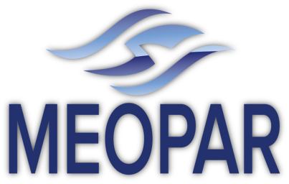

Training Plan

December 2013 – Draft

Introduction

MEOPAR’s Training Plan aims to produce multi--‐skilled people with understanding and expertise across a wide range of disciplines: from the natural and social sciences, to policy and law. The strategy involves creation of a training environment linking natural sciences with economics, social and policy sciences using: i) the Network’s own integrated projects, ii) strong interaction among trainees across the Network, iii) internships that promote cross--‐sector training; iv) direct involvement of partners and stakeholders in the training program, and v) empowerment of trainees to participate in organization of their own training.

MEOPAR-funded projects will involve highly-qualified people (HQP) at various stages of their academic careers including undergraduates, masters, doctoral candidates and post-doctoral fellows. This group is comprised of Canadian and international students and will be resident across the country. The Training Plan will therefore be flexible and responsive, in order to meet the needs of this diverse group. As this will be a network of peers, the term MEOPeers will be used to describe all eligible trainees.
Responsibility
The Training Plan will be the responsibility of the Training and Research Coordinator, who will report to the Executive Director. The Scientific Directors and the Research Management Committee will provide guidance and direction and will ensure that the Training Plan aligns with the MEOPAR Research Plan.
Forms of Training
The training will take a variety of forms including traditional classroom and seminar formats, distance education and one-on-one mentoring. The delivery medium will be dependent upon the topic, location and participants.
There are four preliminary categories of training being proposed:
1) Cross-disciplinary: this would introduce new topics outside of the MEOPeer’s academic discipline. For example, teaching oceanographers a base course in risk management or teaching a sociologist the basics of sea-bed mapping. This training could be delivered by subject matter experts such as MEOPAR investigators or external players or it could be peer-driven. For example, one MEOPeer member delivering a training session in their field to all others.
2) Advanced training within a discipline: this would be smaller in nature and more targeted within disciplines. For example, there may be a new software tool that is of interest to a specific subset of researchers.
3) General training: this would be more generic courses and subjects that will be of use to all members of the MEOPeer network and would include topics such as project management, communication skills, proposal writing, basic finance etc. that will be of use to any member, no matter their discipline or career path.

4) Mentoring: this would include connecting MEOPeer members with a mentor who may or may not come from the same discipline but would be a volunteer with a long successful career in either the public or private sector. MEOPAR will also consider bringing in distinguished speakers to address the entire network from time to time.

In terms of the timing of events, we are proposing at least three face-to-face gatherings of the MEOPeer network for 2014. For all of these gatherings, the travel costs for attendees will come from the MEOPAR training budget. The first will be in Ottawa from February 6-7th. This will be our first major get-together and we will provide two days of training and networking. We will need your help and input to fully structure and organize this event.

The second will be on June 19-20th here in Halifax. There are large MEOPAR meetings planned for that time and it will coincide with our participation in the Coastal Zone Canada conference which will be happening at that time.

The third will be from September 18-19th in St. John's, NL. This will coincide with the Oceans MTS/IEEE 2014 conference and trade show which will be a large gathering of ocean science and industry participants.

